3. Bio-psychosocial Model of Health and Health Care

Knowledge Objectives:
Learners will be able to describe:
- Major classes of psychosocial and behavioral determinants of health: mental health conditions, behavioral disorders, social support and cultural influences, and local physical environment
- Type and prevalence of mental health disorders common among homeless persons.
- Increased medical morbidity and decreased life expectancy associated with chronic mental illness in the public mental health sector.
- Diagnostic criteria for major common addictive substance disorders.
- Major features of traditional addictive substance treatment programs.
- Major features of recovery-oriented and harm reduction substance abuse services.
- Components of the readiness-for-change and self-efficacy models of health behaviors, and their application among homeless patients.

Objective 1: Major classes of psychosocial and behavioral determinants of health: mental health conditions, behavioral disorders, social support and cultural influences, and local physical environment.

Case 1
A 42-year-old man presents to your clinic for hypertension follow up. He is enrolled in a limited county health insurance program provided to persons with very low income. His demeanor is pleasant. He is somewhat talkative and tangential. Blood pressure is 150/95. He reports taking HCTZ 25 mg and lisinopril 20 mg daily.

In addition to medical conditions, what general area is it most crucial to know about to help this patient attain blood pressure control?
- Exercise and other cardiovascular activities
- Who his closest support person is
- Past surgical hospitalizations
- Allergies to medicines

Case 1 Answer
In addition to medical conditions, what general area is it most crucial to know about to help this patient attain blood pressure control?
- Recreational activities. Incorrect. While relevant eventually, more immediate concerns take precedent in this high-risk patient.
- Where his best friend lives. Correct. Understanding this patient’s social support system is crucial to devising effect plans for medication acquisition and adherence.
- Past surgical hospitalizations. Incorrect. This information is not likely to lead to better blood pressure control.
- Allergies to medicines. Incorrect. While important, this information will not directly lead to better blood pressure control.

When working with high-risk patients, such as this individual with extremely low income and evidence of possible psychiatric disorder, clinical care must incorporate understanding of their social determinants of health. Particularly in homeless or uninsured/underinsured populations, it is important to consider socio-economic status, environment, behavioral factors, and access to the health system. The patient’s personal support network of friends and family is closely integrated with these social determinants, and can be essential to achievement and maintenance of health. Indeed, family and social support have been found to have stronger influence on care plan adherence than biomedical factors, even for discreet interventions such as cardiac rehabilitation[1].
Clinicians may uncover highly relevant information by assessing social determinants of health across three psychosocial domains: social supports; community and environmental resources; and behavioral and substance use disorders. When combined with investigation of traditional biomedical and psychiatric domains of need, this screening model yields a simple 5-domain construct:
- Social support
- Resources
- Behavioral and substance use disorders
- Psychiatric disorders
- Biomedical conditions and medications
Assessment of functional status provides information regarding the net effect of these 5 domains on the patient’s life and self-management capabilities (see Figure 1).

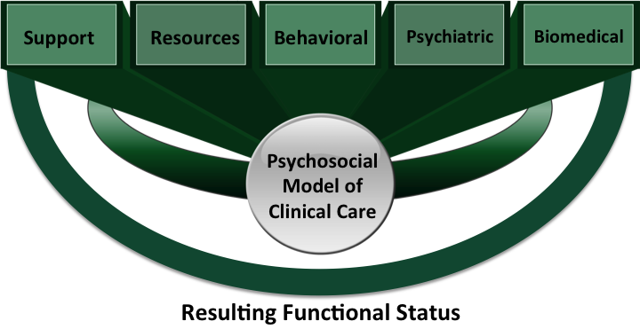

Figure 1: Bio-psychosocial Domains of Care

One or two screening questions covering each of the psychosocial domains is essential to uncover issues with fundamental impact on the patient’s health and function. The following provides a brief introduction to screening within each non-biomedical domain.

Social Support - personal connections, relatives, and friendships
The immediate social support system, or lack thereof, should be determined for all patients with potential mental health and/or substance use problems. Often, the presence of one or two actively supportive relatives or friends is essential to creating a meaningful treatment strategy for mental health and substance use disorders. Negative effects of personal connections should also be considered, such as interpersonal violence. Simple screening questions may include:
- Who lives with you?
- Do you have friends or family who help out when you have difficulties?
- Who are they?
- Do you feel safe where you live?

Community and Environmental Resources – housing, community environment, health insurance, food security, income, and transportation
When subsistence needs are unstable, clinical needs are difficult to address. Competing resource needs (e.g. food, shelter, child care) may limit patients’ ability to adhere with clinical recommendations. Therefore, it is essential to assess the source and stability of income, health insurance, nutrition, and transportation. Simple screening questions may include:
- Where are you staying? Is it a stable living situation?
- How long have you stayed there / will you stay there?
- How much money do you receive regularly each month?
- How do you pay for medical care?
- Where/when/what was your last meal?
- How do you get to medical visits?

Behavioral and Substance Use Disorders – personality disorders, substance abuse, and somatization
Personality Disorders (DSM 5 defined), or dysfunctional behaviors not meeting criteria for personality disorders, are common causes of ineffective and frustrating care for physicians. Personality disorders are best diagnosed by a trained psychiatric professional, given personality issues exist on a spectrum. Hallmark characteristics of the most clinically relevant personality disorders are: extremes of idealization and devaluation, passive aggression, anger and blaming, and dependence.
- Viewing relationships in extremes of idealization and devaluation (sometimes called “splitting”) may manifest as representing other health care providers as inadequate or incompetent, implying that the current health care provider (you) is expected to be better.
- Passive aggression manifests as verbal parrying in which everything suggested or recommended by the health care provider is met with a reason or experience why it has failed, or would be expected to fail.
- Anger and blaming, whether implicit or explicit patient behaviors, often elicit avoidant responses by health care providers, allowing dysfunctional or disruptive behaviors to persist.
- Dependence is the message from the patient that they are victims of their conditions, and that total responsibility for their health improvement lies with the health professional. If unconsciously adopted by the health professional, this implicit belief renders meaningful behavioral change impossible and health improvement improbable.
Substance use disorders are reviewed in more detail within the biomedical module of this curriculum. One simple screening question is: “Have you had challenges with drugs or alcohol?”
Somatization commonly accompanies personality or behavioral disorders, and is commonly overlooked by physicians, leading to unnecessary diagnostic testing and medical therapies. Physicians should be able to detect patterns of physical complaints that shift over time, or are non-anatomical or non-physiological. Detection of somatization, and deciding when to further workup or treat presumed physiologic causes of complaints, is challenging. This usually requires several visits and some diagnostic investigation, but excessive and repetitive testing should be avoided.
Behavioral disorders can generate heavy resource consumption, provider frustration, and ineffective care until recognized and managed. In optimal situations, management of personality disorders may include intensive psychological interventions such as dialectical behavioral therapy, but such supports are often difficult to arrange in homeless, underserved and uninsured populations. Adjunctive medication management for personality disorders and somatization is also available, but for non-psychiatric providers the mainstay of management of behavioral disorders is itself largely behavioral. Therefore, identification of behavioral disorders can be essential to generating an effective clinical management plan.

Psychiatric Disorders– major psychiatric conditions, primarily major depression, bipolar disorder, and schizophrenia
Psychiatric illness is highly prevalent in the homeless population and in other high-risk populations such as those with substance abuse disorders. Further details will be explored later in this module. Example screening questions include:
- Have you ever been diagnosed with a mental health condition?
- Have you ever been hospitalized for a mental health condition?
- Do you have a mental health provider?
- Do you have a mental health case worker?

Functional status
Two methods of measuring functional status are most common in clinical practice:
- Role functioning in significant personal relationships, occupation/employment, social/community roles.
- Activities of Daily Living – used most often in geriatrics settings, a categorical measure of patients’ function in six Basic Activities of Daily Living (eating, bathing, toileting, getting in and out of bed and chairs, dressing, and grooming), Instrumental Activities of Daily Living (medication management, driving, food access and preparation), and walking / gait stability.

Uncovering major psychosocial issues does not oblige the provider to fix, or even address them immediately. Unfortunately, fear of identifying “unfixable” problems is a common barrier to discovering issues of immediate relevance (e.g., choice of medication, facilitating transportation) to medical decision-making. Providers should become comfortable with identifying problems that can be managed or referred to other care team members over time, rather than expecting themselves to manage each psychosocial problem at each visit.

Key Points:
- A 5-domain model can be used for assessment of high risk patients, such as the homeless and underinsured/uninsured:
- Social support
- Community and environmental resources
- Behavioral and substance use disorders
- Psychiatric disorders
- Biomedical conditions and medications
- Social support includes personal connections, relatives, and friendships. These social connections may be positive or negative.
- Resources include housing, community living environment, health insurance, food security, income, and transportation.
- Behavioral and substance use disorders include personality disorders, substance abuse, and somatization.
- Psychiatric disorders include major depression, bipolar disorder, and schizophrenia.
- Clinicians should use 1-2 screening questions in each domain followed by in-depth assessment for positive responses.
- Functional status assessment provides information regarding the net effect of these domains on the patient’s life and self-management capabilities

Objectives 2/3: Type and prevalence of mental health disorders common among homeless persons.

Case 2/3
A 52-year-old man at a homeless shelter has hypertension, diabetes, and asthma. He has been homeless for over ten years. On exam he is pleasant and somewhat talkative. He answers all questions directly and fairly succinctly.

How likely is this patient to suffer from severe mental illness?
- >80%
- 61-80%
- 41-60%
- 21-40%
- <20%

Case 2/3 Answer
How likely is this patient to suffer from severe mental illness?
- >80%
- 61-80%
- 41-60%
- 21-40%
- <20%

Approximately 25-30% of the homeless population has serious mental illness[2, 3]. The incidence of mental illness is considerably higher among people who have been homeless on a long-term basis, with over 60% experiencing lifetime mental health problems[3]. The most common serious mental illnesses are major depression, bipolar disorder, schizophrenia, other psychotic disorders, and anxiety disorders. The prevalence of ‘minor’ mental illnesses that do not meet DSM criteria is also high.
Drug use disorders are also prevalent in the homeless community. Comorbid mental illness and substance-related disorder are commonly known as “co-occurring disorders” (COD) or “dual diagnosis.” Co-occurring mental health disorders are highly prevalent in the general drug-using population, and this is also the case for homeless persons with alcohol and drug use disorders. Indeed, drug use in the homeless population should be considered an indicator of likely mental illness, as approximately 75% of homeless persons with a past-year drug use problem also had a mental health disorder[4]. [More information is provided in the section on tobacco and substance use in the module on Biomedical Conditions among the Homeless].
The high prevalence of mental illness and co-occurring substance abuse disorders has led to the co-location or close collaboration of mental health and substance abuse professionals among homeless populations in many communities. When possible, a team of mental health, addiction, and case management professionals should be provided to most effectively decrease substance use, reduce psychiatric hospitalizations, and improve psychiatric symptoms[5].

Key Points:
- Approximately one-quarter to one-third of homeless persons have severe mental illness.
- Prevalence of severe chronic mental illness is higher among persistently homeless than newly homeless persons.
- Approximately 1 in five homeless persons has co-occurring mental health and substance abuse disorders. Drug use in a homeless person should be considered a likely indicator of co-occurring mental illness.
- Prevalence of ‘minor’ mental health disorders – anxiety and depression - is high among homeless persons.
- Co-location of mental health and medical care is a desirable feature of homeless health care services.

Objective 4: Diagnostic criteria for major common addictive substance disorders.

Case 4
You are seeing a 42-year-old woman in a homeless shelter clinic. She complains of foot pain and swelling, which began after she sat up all night in a bus station. She has been using oral opioids most days lately for the pain. She reports starting to use opioids about one year ago when a friend shared them with her. She has been taking increasingly more pills over the past year because they no longer work as well. She now has to spend a fair amount of her day obtaining pills. When she cannot obtain opioid tablets, she has withdrawal symptoms. Her focus on opioids has caused her to get into arguments at the shelter, so she lost a number of friends.

Based on the current information, what is the most appropriate diagnosis?
- Substance use disorder
- Substance dependence disorder
- Substance abuse disorder
- Substance addiction disorder

Case 4 Answer

Based on the current information, what is the most appropriate diagnosis?
- Substance use disorder Correct. She meets criteria related to both dependence and abuse, and is best described as having DSM-5 criteria for substance use disorder
- Substance dependence disorder
- Substance abuse disorder
- Substance addiction disorder

Diagnostic criteria for substance use disorders are currently defined in the United States and much of the world by the Diagnostic and Statistical Manual. The version IV (DSM-IV-TR)[6] categorization system differentiates two disorders of usage: dependence and abuse, with 7 dependence criteria and 4 abuse criteria (Figure 2). Under these criteria, diagnosis of abuse cannot be made in the presence of dependence.
In the most recent DSM version, DSM-5, the two DSM-IV-TR categories are merged into a single category: substance use disorder. Specific substance use is then identified as appropriate, such as “cannabis use disorder” or “alcohol use disorder.” The new classification combines the DSM-IV-TR criteria for dependence and abuse, such that these states can be recognized as co-existent. One criterion was eliminated (recurrent legal problems) and one was added (craving) (Figure 3). A severity grading system is also now included, based on the total number of criteria met, with at least 2 symptoms required for even mild substance use disorder[7].

Figure 2: DSM-IV-TR Criteria for Substance Dependence and Substance Abuse[6]

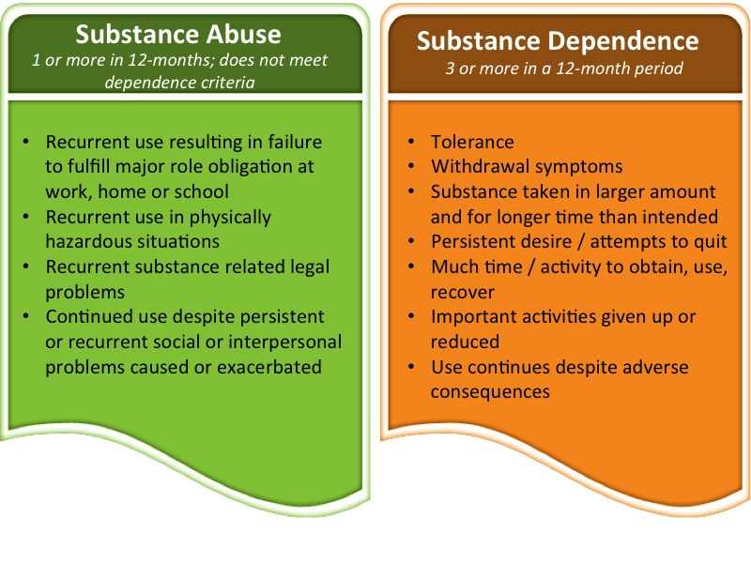

Figure 3: DSM-5 Criteria for Substance Use Disorder[7]

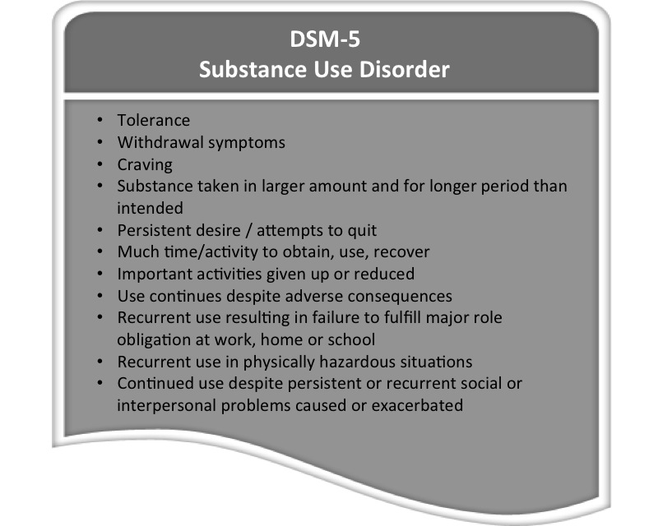

The prevalence of alcohol and other substance use in the homeless population supports routine screening of this high-risk population for substance use disorders. Simple screening methods are widely available. The 4-item CAGE is the briefest and most commonly used screening system for lifetime addictive alcohol behaviors. A single positive response warrants at least brief intervention. Because these questions do not well-differentiate active and current drinking, follow up questioning may be warranted. The four CAGE questions are:
  - Have you ever felt you ought to cut down on your drinking? (Cut down)
  - Have people annoyed you by criticizing your drinking? (Annoyed)
  - Have you ever felt bad or guilty about your drinking? (Guilty)
  - Have you ever had a drink first thing in the morning to steady your nerves or to get rid of a hangover? (Eye opener)
CAGE-AID (CAGE Adapted to Include Drugs) is a convenient drug and substance abuse tool for physicians who are already familiar with CAGE. When CAGE questions are simply expanded to include both alcohol and other drugs, a single positive response provides 79% sensitivity and 77% specificity for detection of drug or alcohol disorder[8]. CAGE-AID questions are:
- Have you ever felt you ought to cut down on your drinking or drug use? (Cut down)
- Have people annoyed you by criticizing your drinking or drug use? (Annoyed)
- Have you ever felt bad or guilty about your drinking or drug use? (Guilty)
- Have you ever had a drink or used drugs first thing in the morning to steady your nerves or to get rid of a hangover? (Eye opener)
More detailed screening tools (AUDIT, MAST, MAST-G) are available online through the Substance Abuse and Mental Health Services Administration at http://www.integration.samhsa.gov/clinical-practice/screening-tools
Following diagnosis of a substance use disorder, the clinician must address the disorder along with co-occurring medical or mental health disorders. Among patients who deny the disorder or refuse to engage in treatment, clinicians should at least complete a diagnostic assessment and let the patient know that s/he is interested in addressing the issue of substance use and will bring it up from time to time. One useful method for engaging active users who deny the existence of a substance abuse problem or who refuse to engage in treatment is to ask: “What are the benefits to you in using substance X?” This should be followed by active, empathetic listening to the patient’s response. Potential benefits of this approach are establishing a basis for future conversations, conveying positive regard to the patient, and eventually identifying treatment options most likely to be successful.

Key points
- Substance abuse disorder is a DSM-IV diagnosis defined as exhibiting one or more of 4 possible criteria in a 12-month period, with specific criteria emphasizing social disruption.
- Substance dependence disorder is a DSM-IV diagnosis defined as 3 or more of 7 possible symptoms in a 12-month period, with an emphasis on tolerance, withdrawal, and drug seeking behaviors.
- Substance use disorder is a newly unified classification in DSM-5 combining criteria of abuse and dependence into a single 11-criterion diagnosis.
- The DSM-5 definition of substance use disorder provides a severity rating system based on the number of criteria met.
- CAGE and CAGE-AID are simple screening tools for alcohol or substance use disorders.
- A simple diagnostic assessment of substance use and co-occurring medical or mental health disorders is appropriate for high risk populations such as the homeless, followed by supportive and empathic listening for those who refuse treatment or deny the disorder.

Objective 5: Major features of traditional addictive substance treatment programs.

Case 5
A 55 year-old man comes for the first time to a primary care clinic at a homeless shelter. He has a long history of alcohol abuse, and has been sober for 2 weeks. He is interested in entering an alcohol treatment program.

Which of the following best describes primary goals of drug treatment programs?
- Abstinence and social functioning.
- Social functioning and housing.
- Medication adherence and avoiding contact with users.
- Daily physical activity and self-reflection.

Case 5 Answer

Which of the following best describes primary goals of drug treatment programs?
- Abstinence and social functioning. Correct. The three generalized goals of substance use treatment programs are: reduced use or abstinence, improved function (vocational, social, or physical), and prevention of relapse.
- Social functioning and housing. Incorrect. Housing support is not a primary goal of most drug treatment programs, although it may be part of a comprehensive recovery care plan.
- Medication adherence and avoiding contact with users. Incorrect. Medication adherence may be a secondary functional goal, but it is not a primary focus of drug treatment.
- Daily physical activity and self-reflection. Incorrect. These may be incorporated into a comprehensive recovery plan, but they are not primary goals.

Treatment programs can be broadly classified according to treatment setting (inpatient, day treatment, and outpatient) and treatment model (usually a combination of medical, psychological, and sociocultural models). Across this classification spectrum, treatment options vary, with no single definition of “treatment”, and no standard terminology describing treatment elements. Moreover, the treatment system differs between states and even between cities.

Treatment Goals
Despite the diversity of settings and models for treatment programs, 3 goals are generally present[9]:
- Reduce substance use or achieve abstinence. Until the patient accepts that abstinence is necessary, treatment usually focuses on harm reduction through education, counseling, and self-help groups that stress reducing risky behavior, building new relationships with drug-free friends, and changing lifestyle patterns. Total abstinence is the final goal and is strongly associated with a positive long-term prognosis.
- Improve life function, such as vocational, social, or physical function. Co-occurring medical and mental illnesses is common, and patients in treatment commonly have relational, vocational, financial, or legal problems. Addressing these problems helps the patient to assume appropriate and responsible roles in society.
- Prevent or reduce the frequency and severity of relapse. Treatment prepares patients for the possibility of relapse, and helps them to understand and avoid triggers of resumed substance use. Treatment targets recognition of cues, handling cravings, and development of contingency plans to manage abstinence “slips”.

Treatment Approaches
Three models regarding the origins of substance use disorders inform substance treatment programs [9]:
- Sociocultural model - stressing deficiencies in the social and cultural environment or socialization process. Treatment responses include changing the physical and social environment, particularly through involvement in self-help fellowships, spiritual activities or supportive social groups. Persons who are in successful recovery themselves may provide sociocultural treatment leadership reflecting their experiential knowledge.
- Psychological model - focusing on maladaptive motivational learning or emotional dysfunction as the cause of substance use. Treatment is provided by a mental health professional who leads psychotherapy or behavioral therapy.
- Medical model - emphasizing biological/physiological and genetic causes of addiction. Treatment responses utilize pharmacotherapy to relieve symptoms or change behavior (e.g., disulfiram, methadone, and medical management of withdrawal).
Recall that in the bio-psychosocial model of care, we organize care needs for high risk patients into 5 domains comprising 3 sociobehavioral domains (social support, behaviors, and resources), a psychological domain and a biomedical domain. The sociocultural, psychological, and medical models of substance use disorders parallel this biopsychosocial construct; indeed, treatment programs usually provide a balanced and combined approach addressing these intertwined domains.
Following completion of active treatment program goals, aftercare is arranged to provide long term support, such as participation in Alcoholics Anonymous or Narcotics Anonymous.

Role of the Primary Clinician in Substance Treatment
Following identification and diagnosis of a substance use disorder, clinicians should pursue referral to a treatment program, if available. In most communities, a public or private agency maintains a directory of substance abuse treatment facilities with useful information about program services. States also usually have an office that publishes a statewide treatment directory. Providers should be familiar with substance abuse treatment programs in their community. Resources for identifying locally available chapters of alcohol and narcotics rehabilitation organizations are provided in the suggested links and resource sections of this curriculum. Of these resources, the National Council on Alcohol and Drug Dependence (www.ncadd.org) and the Substance Abuse and Mental Health Services Administration (SAMHSA) (www.samhsa.gov) provide centralized federal directories linking to local resource information.
A clinician’s continuing care role varies with the patient’s condition and receptiveness to entering treatment, the availability of treatment programs, and the patient’s ability to pay for treatment. A primary clinician may serve as an active collaborative member of the treatment team. At minimum, s/he can continue to address the patient's medical conditions during treatment, encourage continuing participation in the program, and schedule followup visits after treatment termination to monitor progress and help prevent relapse[10].
Biomedically, primary clinicians often perform initial evaluation, stabilization and management of patients transitioning from active substance use to abstinence and who may be candidates for medical detoxification. While beyond the scope of this module, providers may be asked to determine whether patients: a) safely enter and outpatient treatment program, b) require outpatient medical withdrawal therapy (e.g., benzodiazepines for alcohol withdrawal), or c) should undergo inpatient medical withdrawal treatment before transferring to a treatment program. Several algorithms for risk assessment and treatment protocols for medical detox regimens are available[10]. Guides to detoxification are available in the suggested links / resources sections of this curriculum.

Key Points:
- Substance use treatment programs generally incorporate 3 goals: 1) reduction of substance use or achievement of abstinence, 2) improvement of life function, such as vocational, social, or physical function, and 3) prevention or reduced frequency and severity of relapse.
- Substance treatment programs address sociocultural, psychological, and medical concerns that manifest in substance use, with interventions that respond to the biopsychosocial domains of the patient experience.
- Providers should be familiar with substance abuse treatment programs in their community. The National Council on Alcohol and Drug Dependence (www.ncadd.org) and the Substance Abuse and Mental Health Services Administration (SAMHSA) (www.samhsa.gov) provide centralized federal directories linking to local resource information.
- Physicians should be familiar with protocols for assessment and medical management of detoxification for alcohol, benzodiazepines, and opioids. Some national resources are provided in the suggested links section of this curriculum.

Objective 6: Major features of recovery-oriented and harm reduction substance abuse services.

Case 6
Which of the following is most appropriately considered a harm reduction strategy?
- Alcohol abstinence programs.
- Breathalyzer tests at a homeless shelter.
- Random urine drug screening.
- 12-step programs.
- Needle exchange programs.

Case 6 Answer

Which of the following is most appropriately considered a harm reduction strategy?
- Alcohol abstinence programs. Incorrect. Harm reduction strategies mitigate harm from continued use when abstinence is not a realistic goal.
- Breathalyzer tests at a homeless shelter. Incorrect. Breathalyzer tests are most commonly employed in programs that prohibit on-site alcohol use, and do not reduce harm to the individual user.
- Random urine drug screening. Incorrect. Urine drug screening does not itself reduce harm.
- 12-step programs. Incorrect. 12-step programs center on total abstinence, while harm reduction mitigates harm from continued use.
- Needle exchange programs. Correct. When abstinence is not a realistic goal, patients with IV substance addiction disorders are at lower risk of harm from transmissible diseases when provided sterile needles

Traditionally, substance abuse treatment services were categorized as detoxification (‘detox’) – acute weaning from substances over days or weeks, or rehabilitation – programs designed to maintain sobriety or substance free living. In recent decades, two new frameworks for substance treatment services have achieved dominance: harm reduction and recovery-oriented systems of care.

Harm Reduction
This approach focuses on minimizing physical harm and functional impairment through controlled access to substance-related services or resources[11]. Common and widely recognized harm reduction programs for substance users include methadone maintenance programs and needle exchange programs. Harm reduction can be an appropriate strategy when abstinence is not a realistically achievable goal. Although controversy remains, with some favoring a more dichotomized approach to care (abstinent or not), broad evidence supports the effectiveness of this approach without indications of iatrogenic effects[11, 12]. Driven by the demonstrated success of harm reduction in interventions to mitigate the spread of HIV / AIDS, the concept of harm reduction is now applied to a wide spectrum of substance abuse and behavioral disorders.

Recovery-Oriented Systems of Care (ROSC)
A ROSC is a framework for integrated and coordinated community-based systems of care, rather than a specific therapeutic approach. Indeed, a ROSC supports many pathways to recovery. Championed by SAMHSA, “recovery” from alcohol and drug problems is defined as “a process of change through which an individual achieves abstinence and improved health, wellness, and quality of life.”[13]
The ROSC framework for substance abuse treatment emphasizes[13, 14]:
- Integration and coordination of community resources, including social, mental health, and medical health services.
- Early intervention and treatment by multiple approaches, rather than a specific preferred intervention.
Application of the ROSC framework by a treatment center in cooperation with primary medical providers can generate an individualized, person-centered care infrastructure that welcomes and involves substance-using persons and their families into a long-term recovery plan. In addition to long term recovery services, a ROSC provides a comprehensive preventive, educational, and interventional network of services to address the full spectrum of substance use problems and their origins; fully applied, this framework can prevent inappropriate substance use before it occurs and provide early intervention for at risk persons[13].
Websites and resources regarding the ROSC organizing concept are noted on the suggested links/resources section of this curriculum. Specific components of a ROSC framework may include[13]:
- Traditional biomedical, psychological, and counseling services
- Peer recovery coaching
- Alternative and complementary therapies (e.g. acupuncture, meditation, music therapy, art/performance art therapy)
- Vocational and resource supports (e.g. employment assistance, childcare, housing)
- Case management
- Engagement of family and personal connections in recovery planning and activities

Key Points:
- Harm reduction, in contrast to abstinence-oriented treatment, focuses on minimizing physical harm and functional impairment through controlled access to substance-related services or resources (e.g., methadone maintenance, needle exchange programs).
- Recovery-oriented systems of care (ROSC) is a relatively new framework for approaching community-based systems of care for substance abuse conditions that emphasizes the importance of integrated and coordinated social, mental health, substance abuse, and medical health services across a community.

Objective 7: Components of the readiness-for-change and self-efficacy models of health behaviors, and their application among homeless patients.

Case 7
A 62-year-old man presents to a homeless shelter clinic due to a laceration of his foot. He cut his foot when he fell while drunk. He reports: “I have tried to give up alcohol since I was 30,” when he started drinking heavily. Which of the following questions would be most helpful in addressing his alcohol use disorder?

Which of the following would most likely improve this patient’s sense of self-efficacy in overcoming alcohol abuse?
- Do you have friends who have quit drinking?
- What is the best thing about drinking for you?
- What harms have come about because of your drinking?
- When you tried to quit before, why did you start drinking again?

Case 7 Answer

Which of the following would most likely improve this patient’s sense of self-efficacy in overcoming alcohol abuse?
- Do you have friends who have quit drinking? Correct. Social modeling – awareness of successes among persons with whom the patient identifies – tends to enhance individuals’ confidence in behavioral change.
- What is the best thing about drinking for you? Incorrect. This question might help establish rapport with a Pre-Contemplator, but is unlikely to improve self-efficacy.
- What harms have come about because of your drinking? Incorrect. This question is unlikely to improve self-efficacy.
- When you tried to quit before, why did you start drinking again? Incorrect. While addressing roadblocks may be helpful for those contemplating or making concrete plans to quit, this question is unlikely to improve self-efficacy.

Primary care providers play a key role in facilitating patient engagement in health-related behavioral change, such as smoking cessation or abstinence from illicit substance use. Indeed, formal drug and alcohol treatment programs are not readily available in some settings, and other patients may decline to enter or cannot enter a formal program. In this role, primary care clinicians must not operate from the belief that providing information alone will change behavior, as provider-directed instruction for implementing behavior change has proven ineffective[15]. A far more effective approach to facilitating behavioral change is based on two complementary frameworks: readiness-for-change, and self-efficacy[16]. Following assessment of a patient’s readiness-for-change and self-efficacy, those working with patients around health-related behavioral change should provide brief, patient-centered interventions, referrals, and information[17].

Assessing Readiness-for-Change
First pioneered by Prochaska[18] with clinical application explicated by Adams and Grieder[19], the Transtheoretical Stages of Change Model places patients along a spectrum of five states: Pre-Contemplation, Contemplation, Preparation, Action, and Maintenance. These states are not linear and are best considered in a cycle or spiral that acknowledges potential for relapse (Figure 4). Since most providers are generally familiar with the states, the following paragraphs provide tips on how to provide state-appropriate interventions.

Figure 4: Stages of Behavioral Change: Cyclic and Spiral Visual Models

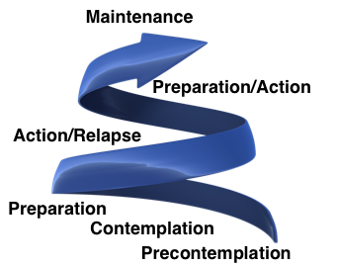
I. Pre-Contemplation (“not interested in change right now”)

Identifying Pre-Contemplators: Some Pre-Contemplators clearly state their lack of desire to change, but others act like Contemplators during health care encounters. An indefinite plan or vague promise to the clinician rather than specific self-directed goals tip-off Pre-Contemplation:
- “I know you want me to stop drinking – I promise I’ll try this year.”
- “Sure I should quit – I’m going to try to cut down.”
- “I just can’t think about quitting smoking now – it’s too much stress.”

Goals of care:
- Provide a safe relationship in which patients can identify and address barriers to change.
- Avoid ‘breeding resistance’ through warnings, chastising, or lecturing.

Health care provider interventions during an encounter: Providers should use active listening skills and motivational interviewing methods to explore the patient’s experiences, build a therapeutic alliance, and demonstrate nonjudgmental acceptance of them as a person. Example questions include:
- “Could you tell me a bit about your relationship with (drug X use, alcohol, smoking)?”
- ”What are the good things for you about (using drug X, alcohol, smoking)?” Answers usually include some surprise that a doctor is interested in the positive aspects of negative behavior, and avoids patients’ feeling stigmatized by physicians.
- “It’s great to know that about you – I’d like to continue learning about where (drugs, alcohol, cigarettes) fit in your life in future visits.”

II. Contemplation (“interested in change but not ready to make a specific plan”):

Identifying Contemplators: Formally defined, Contemplators are those who have committed to make a behavioral change within the next 6 months, but an active self-determination intention of longer term can clinically be treated as Contemplation.
- “I’ve been thinking this is a good year to finally quit.”
- “I really need to quit drinking – my brother just got in a car accident and he’s a heavy drinker too.”

Goals of care:
- Establishing a ‘road map’ to successful change, with early goal setting.
- Positive reinforcement and encouragement.
- Information, resources and follow-up plan, motivating toward Preparation.

Health care provider interventions during an encounter: Providers should engage in motivational techniques to assist the Contemplatory person into active Preparation, using encouragement and solution-focused discussion.
- “Great! Once you stop, immediate health benefits will include (fewer respiratory infections [smoking].” [Information and reinforcement]
- “Have there been periods in the past when you quit? Great! So you know you can be successful – you’ve done so in the past.” [Re-framing]
- “Are you ready to set a DATE to (start your new behavior)?” [Facilitate transition to Planning]
- “To succeed we’ll eventually need to discuss details of a plan for change that will work for you, along with ways of following your progress.” [Establishing a roadmap and early goal setting]

III. Preparation (ready to chart specific steps to change):

Those in the preparation stage are usually easy to identify. Providers usually feel gratified when encountering these patients, and eager to help out:
- “I’m ready to get off Vicodin”.
- “I’d like your help to quit smoking.”

Goals of care:
- Establish a practical plan of action to accomplish the desired change.
- Plans should reflect barriers, motivators, and triggers relating to the 5 bio-psychosocial domains (personal relationships, behaviors, resources, psychiatric needs, and biomedical needs).
- Set achievable goals, such as those following the mnemonics SLAM (specific, limited, achievable, measureable) or SMART (specific, measurable, achievable, realistic, timely). “I will attend an AA meeting at the church tonight and at least once a day.” “At the end of this visit I will call the intake phone number for the local substance use treatment center.”
- Establish a follow up plan for reinforcing and assessing progress toward goals.

Health care provider interventions during an encounter: Discussions should be organized around the SLAM/SMART mnemonics in order to establish a practical and achievable plan in preparation for Action. The patient should generate as many specific ideas as possible, with the provider serving as coach and suggesting necessary refinements or modifications to the plan.

IV. Action (first six months of starting a planned behavioral change):

Active implementation of behavioral change may require follow up that is highly biomedical and frequent (acute alcohol detoxification) or may incorporate referral to an inpatient substance abuse treatment center. Other action plans may be less biomedically intensive and partner with a ROSC (opioid addiction) or remain within a primary care setting (smoking cessation). In any scenario, clinical care includes patient-led discussion of the degree to which goals have been met, their results, barriers to change, and facilitators to success. Goals and plans are modified based on initial experience. Often, patients will have experienced some success but not as much as they would like. In these cases the provider’s role is to reinforce the successes and help the patient set appropriate, often more limited, goals.

Maintenance (after the first six months, new behaviors have become routine):

The clinician’s role is to ‘check in’ (usually annually) on the continuation of the positive behavior, and help the patient identify success factors or potential threats to continued success. Assessing the status of the biopsychosocial domains of the patient’s experience can be helpful in addressing these factors.

Promoting Self-efficacy
Behavioral research has demonstrated that a necessary pre-requisite to behavioral change is self-efficacy - the judgment of one’s own competence to succeed in any given behavior[16].
For patients in states of contemplation or planning, clinicians can perform a simple assessment of self-efficacy by asking: “How confident are you that you are ready to (or will be able to) implement these changes?” Active listening and counseling should then incorporate one of four commonly recognized methods of enhancing patient self-efficacy (with social cognitive theory labels noted in parentheses)[16, 20]:
- Emphasize previous successes (“mastery experiences”).
- With the patient, identify people with whom the patient identifies who have successfully implemented behavior change (“modeling”).
- Express confidence that you, the clinician, believe the patient can succeed (“persuasion”).
- Educate the patient on what to expect physically during the planned change. This is particularly essential for patients planning to enter substance withdrawal. (“adaptation to physiological and affective states”).

Key Points:
- Providers should assess and respond to patients’ Stage of Change along the spectrum of Precontemplation, Contemplation, Planning, Action, and Maintenance.
  - Precontemplators should be provided with a safe provider relationship in which they can identify and address barriers to change; providers should avoid breeding resistance through warnings, chastising, or giving instruction.
  - Contemplators are open to assistance and should be offered: a ‘road map’ to successful change, early goal setting, encouragement, information, and follow-up plans.
  - Planners require a practical plan reflecting barriers, motivators, and triggers relating to the 5 bio-psychosocial domains, and that incorporates achievable SLAM/SMART goals.
- Care planning and interventions should assess and promote a patient’s sense of self-efficacy (confidence in the ability to change).

References

1. Clark, A.M., et al., A qualitative systematic review of influences on attendance at cardiac rehabilitation programs after referral. Am Heart J, 2012. 164(6): p. 835-45 e2.
2. US conference of mayors 2012 status report on hunger and homelessness: a status report on hunger and homelessness in America's cities, a 25-city survey, 2012, US conference of mayors' task force on hunger and homelessness: Washington, D.C.
3. Current statistics on the prevalence and characteristics of people experiencing homelessness in the United States, 2011, Substance Abuse and Mental Health Services Administration: Washington, D.C.
4. Kertesz, S.G., et al., Substance abuse treatment and psychiatric comorbidity: do benefits spill over? Analysis of data from a prospective trial among cocaine-dependent homeless persons. Subst Abuse Treat Prev Policy, 2006. 1: p. 27.
5. Hwang, S.W., et al., Interventions to improve the health of the homeless: a systematic review. Am J Prev Med, 2005. 29(4): p. 311-9.
6. American Psychiatric Association., Diagnostic criteria from DSM-IV-TR. 2000, Washington, D.C.: American Psychiatric Association. xii, 370 p.
7. Kane, G. DSM-5 - Coming May 2013. 2013 [cited 2013 March 21]; Available from: http://www.ncadd.org/index.php/get-help/addiction-medicine/482-dsm-5-coming-may-2013.
8. Brown, R.L. and L.A. Rounds, Conjoint screening questionnaires for alcohol and other drug abuse: criterion validity in a primary care practice. Wis Med J, 1995. 94(3): p. 135-40.
9. Chapter 5 - Specialized substance abuse treatment programs, in A Guide to Substance Abuse Services for Primary Care Clinicians, Treatment improvement protocol (TIP) series, no. 24. 1997, Substance Abuse and Mental Health Services Administration (US): Rockville (MD).
10. in Detoxification and Substance Abuse Treatment: Treatment Improvement Protocol (TIP) Series, No. 45. 2006, Substance Abuse and Mental Health Services Administration (US): Rockville (MD).
11. Harm reduction: evidence, impacts and challenges. [monograph] 2010 February 12; Available from: http://www.emcdda.europa.eu/publications/monographs/harm-reduction.
12. Logan, D.E. and G.A. Marlatt, Harm reduction therapy: a practice-friendly review of research. J Clin Psychol, 2010. 66(2): p. 201-14.
13. Recovery-Oriented Systems of Care (ROSC) Resource Guide. 2010 [cited 2012 December 2]; Available from: http://partnersforrecovery.samhsa.gov/docs/rosc_resource_guide_book.pdf.
14. Halvorson, A., J. Skinner, and M. Whitter, Provider approaches to recovery-oriented systems of care: four case studies. HHS publication No. (SMA) 09-4437, 2009, Center for Substance Abuse Treatment, Substance Abuse and Mental Health Services Administration: Rockville, MD.
15. Braddock, C.H., 3rd, et al., Informed decision making in outpatient practice: time to get back to basics. JAMA, 1999. 282(24): p. 2313-20.
16. Webb, T.L., F.F. Sniehotta, and S. Michie, Using theories of behaviour change to inform interventions for addictive behaviours. Addiction, 2010. 105(11): p. 1879-92.
17. Frosch, D.L. and R.M. Kaplan, Shared decision making in clinical medicine: past research and future directions. Am J Prev Med, 1999. 17(4): p. 285-94.
18. Prochaska, J.O., Systems of psychotherapy : a transtheoretical analysis. 8th Ed. ed. 2013, Belmont, CA: Brooks/Cole Cengage Learning.
19. Adams, N. and D. Grieder, Treatment planning for person-centered care : the road to mental health and addiction recovery : mapping the journey for individuals, families and providers. 2005, Bulington, MA: Elsevier Academic Press. xxi, 291 p.
20. Bandura, A., Health promotion by social cognitive means. Health Educ Behav, 2004. 31(2): p. 143-64.

