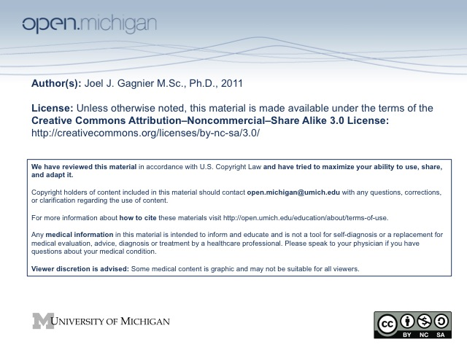

Introduction to Systematic Reviews and Meta-Analyses
Epid 757
Summer 2011

SYLLABUS

2011
Graduate Summer Session in Epidemiology
University of Michigan
School of Public Health
July 25-29, 2011

SYLLABUS

Number: Epid 757

Title: Introduction to Systematic Reviews and Meta-analysis

Credit Hours: One

Instructor: Dr. Joel J. Gagnier MSc, PhD
Departments of Orthopaedic Surgery and Epidemiology
University of Michigan, School of Public Health
109 Observatory Street, M5158 SPH-II
Ann Arbor, MI, USA
(734)615-6934
Description:
Systematic reviews and meta-analyses are useful for evidence-based clinical and public health practice. The widespread and growing application of systematic review methods for the synthesis of evidence on important or pressing research and clinical questions underscore the need for health-care professionals to understand and critique this research design. This course will provide a detailed description of the systematic review process, discuss the strengths and limitations of the method, and provide step-by-step guidance on how to actually perform a systematic review and meta-analysis. Specific topics to be covered include: formulation of the review question, searching of literature, quality assessment of studies, data extraction, meta-analytic methods, assessment of heterogeneity and report writing. The course will also cover statistical issues such as selection of statistical models for meta-analysis, practical examples of fixed and random effects models, best evidence syntheses (qualitative systematic reviews) as well as examples of methods to evaluate heterogeneity and publication bias. STATA statistical software will be used to perform meta-analysis during the computer lab, along with tutorials on how to effectively use tools such as PubMed for conducting reviews.
Prerequisites: Basic courses in epidemiology and biostatistics
Format:
Five 3.5 hour classes in week 1 involving a mix of instructor presentation, small group discussions, and general class discussions. The last hour of so of each class will be devoted to an individual exercise.
Requirements for course credit:
Students are required to complete a protocol for a systematic review that is due the Monday following the course (see assignment details below). Course credit requires attendance in at least four of the five classes and students are expected to participate in class discussions
Day | Topics | Chapters from Text A | Chapters from Text B
Monday | -Introduction to synthesis research  -Formulating a topic and developing a protocol | 1, 2, Sample proposal, PRISMA statement
Tuesday*** | Mark MacEachern, MLIS  -Searching and screening the literature  -Data extraction and evaluating the quality of studies | 3,4, lecture 2 handout: Searching the literature
Wednesday | -Analyzing and integrating the outcomes of studies (Data synthesis methods) | 5 | 11, 12, 13,32
Thursday | -Assessing variations in effect  -Computer Lab | 6 | 15,16,19,20, 30,40
Friday | - Interpreting the evidence & presenting the results  -Critical appraisal of systematic reviews | 7, PRISMA statement | 41,
Class topics and Schedule: Monday to Friday, July 12-16th, 1:30-5:00pm
***Note: It will be very useful to bring a laptop with you, especially for Tuesday’s class which involves a searching demonstration.

Course text A: Littell JH, Corcoran J, Pillai V. Systematic Reviews and Meta-analysis. Oxford: Oxford University Press, 2008.
Course text B: Borenstein M, Hedges LV, Higgins JPT, Rothstein HR. Introduction to Meta-Analysis. New Jersey: John Wiley and Sons, 2009.
***Note: It will be very useful to bring a laptop with you, especially for Tuesday’s class which involves a searching demonstration.
Assignment details: 100% of the course mark
Attendees who are seeking course credit are required to complete a protocol for a systematic review. They should detail their plans for a systematic review of their interest by outlining all proposed rationale, objectives and methods. The format and details included in the sample protocol can be followed as a guide. This assignment is due the Monday following the course; Monday July 19th, 2010.

