

ISIS CURRICULUM

Assessment and Management of
Intrapartum Fetal Monitoring

Created: March 01, 2010
Modified: August 20, 2012

1 | Author Contact Information
2 | Description of Curriculum
3 | Prerequisite Knowledge and Skills
4 | Goals and Objectives
5 | Instructor Notes and Common Questions
6 | Cognitive Training
7 | Skill Training
8 | Equipment Setup
9 | Assessment Methods
10 | Appendices

Lucas McIntyre
Medical Student
University of Washington
1959 NE Pacific Street
Seattle WA 98195
Email: mcintyl@uw.edu

Michael Fialkow, MD MPH
Assistant Professor
Obstetrics and Gynecology
Box 356460
University of Washington
1959 NE Pacific Street
Seattle WA 98195
Phone: (206) 543-3045
Fax: (206) 616-9479
Email: mfialkow@u.washington.edu

Katherine O’Connell, MN RN
Perinatal Clinical Nurse Specialist
Obstetrics and Gynecology
Box 356460
University of Washington
1959 NE Pacific Street
Seattle WA 98195
Email: koconnll@uw.edu

Leslie Carranza, MD
Acting Assistant Professor
Obstetrics and Gynecology
Box 356460
University of Washington
1959 NE Pacific Street
Seattle WA 98195
Email: carr0368@washington.edu

Thomas J Benedetti, MD, MHA
Professor
Obstetrics and Gynecology
Box 356460
University of Washington
1959 NE Pacific Street
Seattle, WA 98195
Phone: (206) 543-3729
Email: benedeti@u.washington.edu

Acknowledgements:
Megan Sherman
Joshua Fast

Course Overview:

The most common prelude to most obstetric emergencies is fetal intolerance of labor, typically demonstrated by changes in the fetal heart rate. For a newly starting OB/GYN resident this can be among the most stressful early experiences on the Labor and Delivery (L&D) ward. Proper interpretation and management of the fetal heart rate tracing (FHR tracing) is a critical skill for the obstetric provider that is traditionally acquired through exposure to static images of FHR tracings and hands-on clinical experience on L&D. The advent of high fidelity simulators, in particular the Noelle pregnant mannequin, allows for the lifelike simulation of intrapartum fetal heart rate patterns of multiple etiologies. This didactic curriculum will provide obstetric providers standardized teaching in the evaluation and management of intrapartum fetal heart rate patterns and the Noelle high-fidelity pregnancy and delivery simulator that will allow those providers to do this in a realistic fashion and setting. This curriculum also reinforces the use of the TeamSTEPPS communication techniques but any team communication technique would be suitable.

The training session will involve (1) a didactic session and (2) hands-on training sessions in the evaluation and management of intrapartum fetal heart rate patterns on a high-fidelity mannequin. Whenever possible, a video recording of all simulations will be made to assist with the debriefing of trainees’ technical and communication skills (See Appendix A).

The testing sessions will ultimately involve incorporating this training module into several possible obstetric emergencies so that the trainee must recognize and then manage the problem without any forewarning.

Educational Rationale on How the Course Generalizes to Real-Life Circumstances:

This course is designed to give obstetric care providers an opportunity to (1) interpret intrapartum fetal heart rate tracings in a realistic setting, (2) discriminate the variety of causes and management plans and (3) practice communication techniques known to improve team communication (see appendix F).

Duration of Training Session: 30 minutes
Duration of Testing Session: 10-15 minutes
Duration of Simulation: 3-10 minutes
Duration of Debrief: 15-30 minutes

Frequency of Course per Trainee:
3rd Year Medical Students Once, optimally during orientation
OB/GYN Resident: Annual, particularly during orientation for the Interns
Family Medicine Resident: Annual, particularly during orientation for the Interns
Nursing Student: Once, optimally during orientation to L&D

Range of Trainees per Session: 4-8

OB/GYN and Family Medicine medical students and residents, nursing students

While trainees participating in the course will have varied backgrounds and experiences, all will be obstetric care providers and therefore at risk to encounter episodes of category II or III fetal heart rate tracings.

Prior to receiving training in this course, trainees should have the following background knowledge:

Medical Knowledge: Fundamental understanding of labor and delivery; utero-placental physiology

Clinical Skills: History and physical of the pregnant patient at term. Team communication

ACGME Competencies: (1) Medical Knowledge, (2) Patient Care,(3) Interpersonal and Communication Skills, (4) Professionalism,(5) System-based Practice, (6) Practice-based Learning and Improvement

Goal 1: Experience a Scenario Involving the Management of a Category II or III Fetal Heart Rate Tracing
The learner will experience a scenario involving the management of a category II or III fetal heart rate tracing in a simulated setting.

- Objective 1: The learner will be able to identify category II or III fetal heart rate tracings. (1, 2)
- Objective 2: The learner will be able to apply new knowledge to pregnancies complicated by category II or III fetal heart rate tracings. (1, 5, 6)
- Objective 3: The learner will implement a standardized algorithm, that address the causes of category II or III fetal heart rate tracings. (6)
- Objective 4: The learner will apply maternal-fetal physiologic principles in the analysis of fetal heart monitoring. (1)
- Objective 5: The learner will analyze a fetal heart rate tracing and select the correct assessment, technique, interpretation, intervention, and evaluation for promoting fetal well-being. (1, 5)
- Objective 6: The learner will have improved confidence in interpreting and managing indeterminate and abnormal FHR tracings. (6)

Goal 2: Teamwork and Interprofessional Communication
The learner will interact with nursing staff and a simulated patient in a stressful simulated setting.

- Objective 1: The learner will demonstrate components of communication with his or her team that is in line with TeamSTEPPS or a similar teamwork and team communication system*. (1, 2, 3)
- Objective 2: The learner will use components of communication that facilitate and maintain the patient’s understanding of the situation as it develops. (2, 3, 4)

Goal 3: Self-assessment of Technical and Communication Skills
The learner will review the video-recorded simulation session with the instructor, and identify areas for improvement relating to technical and communication skills.

- Objective 1: After reviewing the video, the learner will be asked to identify aspects of the simulation, including both communication and management, that were both successful and that need improvement. (3, 6)
- Objective 2: The learner will be asked to evaluate his/her performance during the simulation event by completing a self-assessment form. (5)

Goal 4: Documentation of Events
The learner will document the key components of an episode of category II or III fetal heart rate tracings for the medical record.

- Objective 1: The learner will accurately and thoroughly document the episode of category II or III fetal heart rate tracing for the medical record, recording the key management events, personnel present, and outcome of the neonate and patient. (1, 2, 5)
- Objective 2: The learner will utilize National Institute of Child Health and Human Development (NICHD) terminology in EFM review. (1, 2)

(Optional) Goal 5: Disclosure of Errors
The learner, for certain scenarios, will have the opportunity to interact with the patient’s spouse (actor), away from the patient care setting, and to disclose an error that occurred during management, whether real (caused by the trainee during the scenario) or imposed (created by the trainers for the purposes of practicing disclosure) (ACGME: Interpersonal and Communication Skills and Patient Care). Guidelines for error disclosure in references.

- Objective 1: The learner will accurately and compassionately disclose the error(s) that occurred during the event to the patient’s spouse. (2, 3, 4, 6)
- Objective 2: The learner is expected to be (3, 4):
  - Honest
  - Accurate
  - Apologetic
  - Sincere

*TeamSTEPPS (Strategies and Tools to Enhance Performance and Patient Safety) is a teamwork system developed by the Agency for Healthcare Research and Quality with the DOD to improve patient safety through optimization of communication and teamwork skills among health care professionals.
www.teamstepps.ahrq.gov

Prepare the simulation room as described and shown in Section 9.

At the start of each training/testing session:
• Orient trainees to the simulation and the simulated setting.
• Explain that cameras will be used for the debriefing.
• Read the introduction for the overall scenario.
• The trainee is called to the room and provided an SBAR* by the instructor playing the appropriate role according to the scenario selected.

Execution of the simulation by the trainer
• Instruct the trainee to verbalize each step of the exercise. When the trainee wants to do a procedure or administer a medication, they should communicate what they want to do, and verbalize each step of the process (“thinking out loud”).
• The simulation lasts until successful or definitive management of the event, or about 10 minutes (ended by trainer), whichever comes first.
• Following the simulation, instruct the participants to write an event note.
• Option: Following the simulation, instruct the trainee to disclose the errors to the patient’s spouse (played by a confederate).
• Following the simulation, conduct a brief debriefing session to discuss the experiences of each participant, and to address concerns regarding implementing the skills learned into practice on L&D.
• At a later date, using the videos of the simulation, conduct a group debriefing emphasizing the key points of debriefing in Appendix B.

Instructions to Trainees:
“Remember to”:
- Treat the scenario as real as possible
- Use mask/gloves/gown as needed
- You may ask for medications as needed
- Request assistance if needed
- Ignore the camera if one is present
- Ask questions if you have them

Answers to Common questions
General
“Call pediatrics?” - If they ask for pediatrics or other help, tell them that they are on their way – if pediatrics is involved in the simulation, they can then arrive.
“What else do we know about the patient?” - You do not have any more history than what the trainee received when they walked into the room, and the background information provided in the scenario description.
“Can you give her X?” - You do not know any of the medication doses or routes, but can give anything they ask for.
“Can you get me X instrument?” – No additional instruments are available.

* TeamSTEPPS terms in Bold ALL CAPS (see Appendix F for definitions)
Answers to Common questions cont’d
General
“What are the patient’s vitals?” – Restate the original scenario vitals if not provided on the monitor.
“Let's move to the OR?” – (Please refer to Appendix A for scenario details). The two lower-level scenarios are set in OR1 so this is not necessary. For the two upper-level scenarios, moving to the OR is part of the scenario, but they may only move to the OR with the intention of doing a Cesarean, not simply to be “in place” if something goes wrong.
“Let's move to Cesarean?” – This is OK if proper management of the category II or III fetal heart rate tracings did not relieve the heart rate changes. For the two lower-level scenarios this effectively ends the scenario. For the two upper-level scenarios moving to the OR for a Cesarean is part of the simulation and should be managed as realistically as possible.

Additional Scenario Management Information
- Poor or awkward communication with patient and or the nurse
  - Example: “Patient” continues to ask unanswered questions “What is going on? What’s wrong with the baby? It hurts!”
  - Management: The instructor and trainee will debrief the scenario video to identify when further communication with the patient might have been helpful.
- Difficulty understanding role of assistant(s), and using the assistant(s) to help with management
  - Management: To alleviate confusion, the “nurse” will be identified prior to beginning of the scenario
  - Management: To solidify the role, the nurse may ask the trainee questions about what he/she could do to aid the trainee during the exercise.

Debriefing
  - Please refer to Appendix B for detailed debriefing notes.
  - Learners are accompanied to the debriefing room.
  - A video recording is available to review key parts of the simulation.
- Key points for the debriefing:
    - Facilitate a discussion rather than giving a lecture.
    - Learners should discuss why they chose certain courses of action and discuss the consequences. Ask if would do the same or differently if they did the same scenario again.
    - Engage everyone in the discussion, particularly quiet team members.
- Key topics for discussion should include:
    - Strategies to recognize and manage category II and III fetal monitor tracings
    - Principles of teamwork and communication in crisis management (Appendix F)
    - Communication principles with patients and their families
    - Proper documentation
    - Disclosure of errors
    - Participants’ self-assessment of stress levels

* TeamSTEPPS terms in Bold ALL CAPS (see Appendix F for definitions)

Overview
This section will provide Labor and Delivery (L&D) providers with the information they need to have a basic understanding of how to read fetal heart rate tracings to determine whether or not category II or III fetal heart rate tracings are occurring.

Category II or III fetal heart rate tracings, demonstrated by indeterminate or abnormal fetal heart rate tracings, are the most common ‘worrisome’ experiences in the management of labor. Category III, or abnormal tracings, are the most common prelude to obstetric emergencies that can have significant morbidity and mortality for the infant if improperly assessed and managed. Proper interpretation and management of the fetal heart rate tracing (FHR tracing) is therefore a critical skill for the obstetric provider that is traditionally acquired through lecture and textbook-based exposure to static images of FHR tracings and hands-on clinical experience on L&D.

Specifically, this section will provide an overview of fetal heart rate monitors and what can be observed on them, which includes fetal heart rate baseline, baseline variability, bradycardia, tachycardia, accelerations, early decelerations, late decelerations, variable decelerations, prolonged decelerations, sinusoidal patterns and recurrent decelerations.

Types of Fetal Heart Monitors
External Monitor:
An electronic fetal monitor ultrasound transducer is a small hockey puck-shaped device. It is placed on a mother’s stomach over the fundus of the uterus and uses Doppler technology to measure the fetal heart rate. The data are used to produce a fetal heart rate tracing (FHR tracing) on graph paper and/or on a computer. In the picture below, the FHR tracing is recorded on the upper graph and uterine contractions are recorded on the lower graph.

Internal Monitor:
The fetal spiral electrode is a small wire that is placed through the fetal skin on the scalp or buttocks. It conducts electrical current and graphs the fetal ECG data on to the graph paper and/or computer. Insertion requires rupture of membranes and cervical dilatation.

Internal Monitor Reading
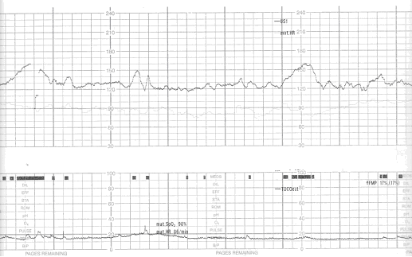
Source: Katherine O’Connell

NOTES: The fetal heart monitor paper records at 3 cm/min
Each small box = ten seconds
Each large box = 60 seconds
Two graph sections
Top = Fetal heart rate
Bottom= Uterine contractions
Graph paper is fan folded and the pages numbered consecutively

Types of Uterine Contraction Monitors
In addition to the fetal heart rate, uterine contractions are monitored and appear on the lower graph. This allows the provider to compare the fetal heart rate to the contractions to determine what the relationship is between them. There are two types of uterine contraction monitors that are used: an external uterine tocodynamometer (a.k.a., “toco”) or an intrauterine pressure catheter (IUPC).
• External Monitoring - Uterine Tocodynamometer (a.k.a., “toco”)
Assesses frequency and duration of contractions, but NOT strength
Non-invasive
Needs proper placement to function
Limits patient mobility
May be difficult in obese women
• Internal Contraction Monitoring - IUPC – Intrauterine Pressure Catheter
Invasive—requires rupture of membranes
May be transducer-tipped or fluid-filled
Accurately assesses intrauterine pressure in mmHg
Risks:
Uterine perforation or extraovular insertion
Infection or hemorrhage

Fetal Heart Rate Interpretation
Fetal heart rate tracings should be interpreted based on:
            - Baseline rate
            - Variability
            - Accelerations
            - Decelerations
            - Uterine contractions
            - Fetal heart rate trends

Currently a three-tiered system is used to characterize fetal heart rate tracings. This section will provide an overview of this system as well as information on six types of fetal heart rate patterns that you should know.

Category I – Normal (formerly known as “reassuring”)
Characterized by including ALL of the following:
    - Baseline rate: 110-160 bpm
    - Moderate baseline variability
    - No variable or late decelerations
    - Present/absent early decelerations
    - Present/absent accelerations

Strongly predictive of normal fetal acid-base status at the time of observation.

  - Management: routine with no specific action

Category II - Indeterminate
Characterized by ANY of the following:
    - Baseline tachycardia
    - Baseline bradycardia with variability
    - Minimal baseline variability
    - Absent baseline variability w/o recurrent decelerations
    - Absent accelerations (with or without induced stimulation)
    - Recurrent variable decelerations with minimal/moderate baseline variability
    - Variable decelerations with other characteristics, such as slow return to baseline, overshoots, shoulders
    - Prolonged decelerations (≥2 minutes but <10 minutes)
    - Recurrent late decelerations with moderate baseline variability
- Category II tracings are not predictive of abnormal fetal acid-base status but there is not enough evidence at present to classify these tracings as either Category I or III.

  - Management:
    - Continued surveillance, evaluation and reevaluation, taking into account the entire associated clinical circumstances

Category III – Abnormal (formerly known as “nonreassuring”)
Characterized to include either:
    - Absent baseline variability and any of the following:
      - Recurrent late decelerations
      - Recurrent variable decelerations
      - Bradycardia
    - Sinusoidal pattern
- Category III tracings are predictive of abnormal fetal acid-base status at the time of observation and require prompt evaluation.

  - Management:
    - Depending on the clinical situation, prompt efforts should be made to resolve the abnormal FHR pattern or effect delivery.
    - Category III tracings do have a high false positive rate and it is therefore important to work through all possible interventions rather than move immediately to Cesarean section.

1. Baseline Fetal Heart Rate

source: Katherine O’Connell

- Characteristics:
- The approximate mean fetal heart rate (FHR) is rounded to increments of 5 bpm during a 10 min segment
Average 110-160 bpm
- The rate plus variability (discussed below) gives the indication of range (i.e., baseline is 135 with moderate variability implies that the baseline of 135 can vary by 6-25 bpm, so at minimum ranging from 129-141 bpm, to at maximum, ranging from 110-160 bpm )
- Excludes:
  - Periodic or episodic changes (determined between periodic [contractions] or episodic changes)
  - Periods of marked FHR variability
  - Segments of the baseline that differ >25 bpm

In any 10 minute window, the minimum baseline duration must be at least 2 minutes or the baseline for that period is indeterminate. In such a case, one may need to refer to the previous 10 minute segment(s) to determine the baseline, or continue review until at least 2 minutes of baseline can be identified.

- Variability:
Visual assessment of the amplitude of both short and long term (jitteriness and waviness) complexes, with exclusion of the regular smooth sinusoidal pattern.

Fluctuations in the baseline FHR of 2 cycles/minute or greater. These fluctuations are irregular in amplitude and frequency and are visually quantified as the amplitude of the peak to trough in bpm.

Causes of baseline variability changes:
Increased Variability Decreased Variability
Fetal stimulation Fetal sleep
Drugs Prematurity
Medications Medications Artifact Hypoxia
Cardiac arrythmias
Fetal Anomalies
Drugs

a. Absent Variability
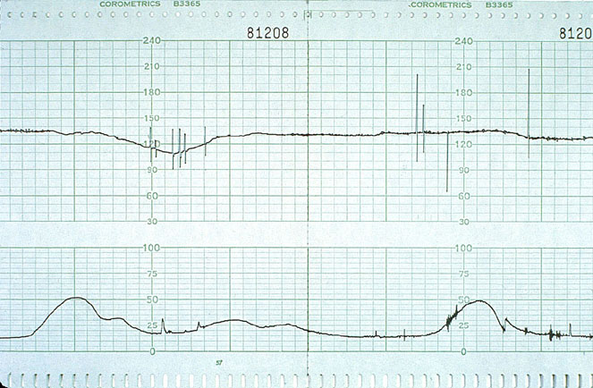
Source: Thomas Benedetti

b. Minimal Variability: Greater than undetectable and ≤ 5 bpm
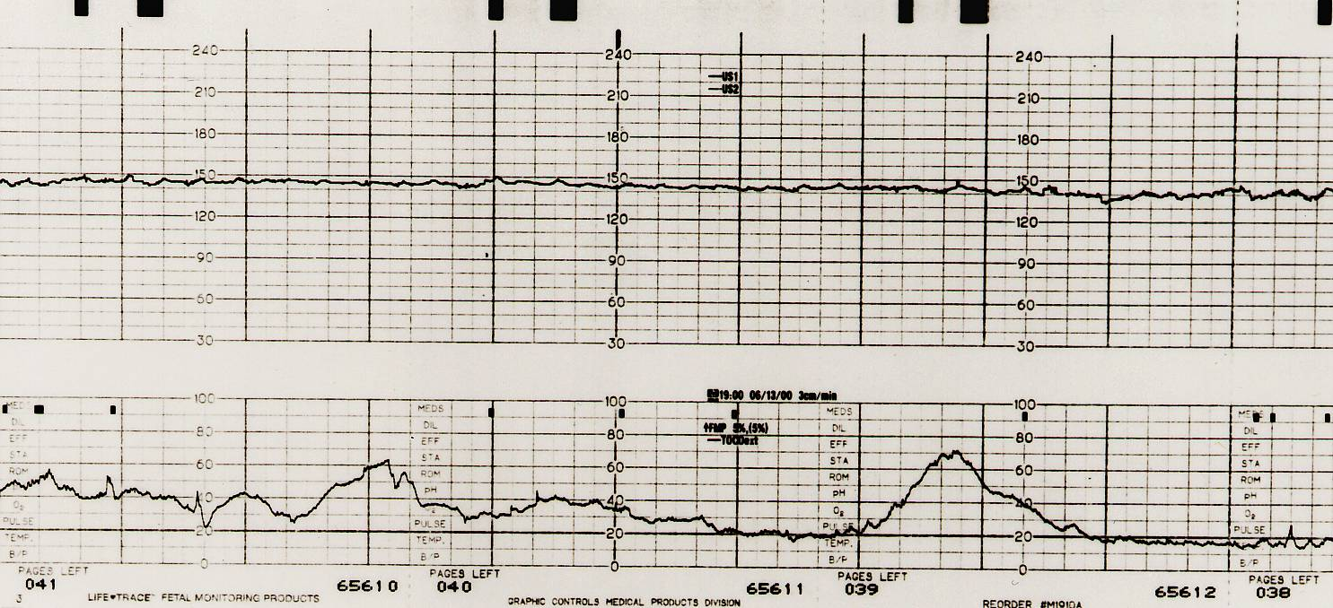
Source: Thomas Benedetti

c. Moderate Variability: 6-25 bpm
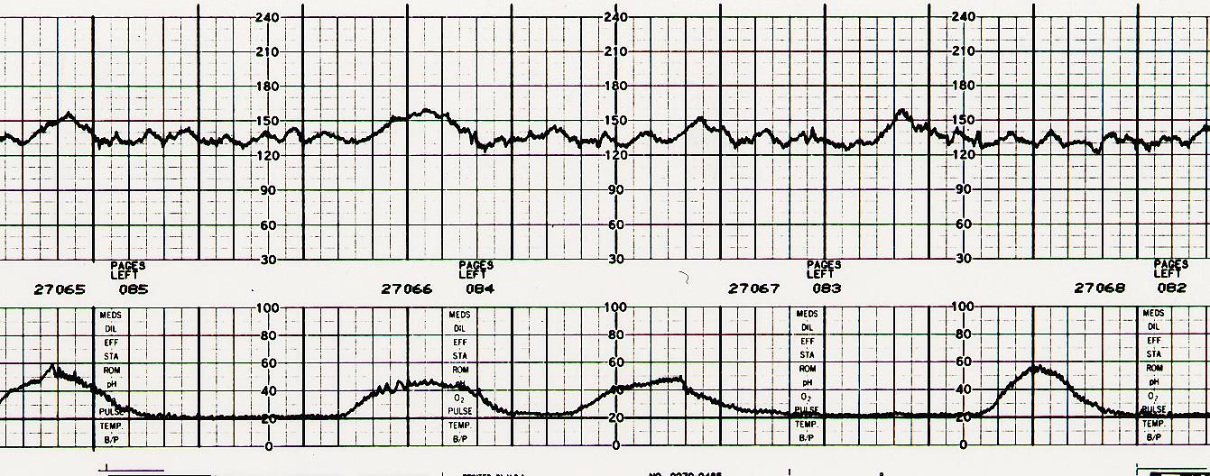
Source: Thomas Benedetti

d. Marked Variability (Saltatory): > 25 bpm
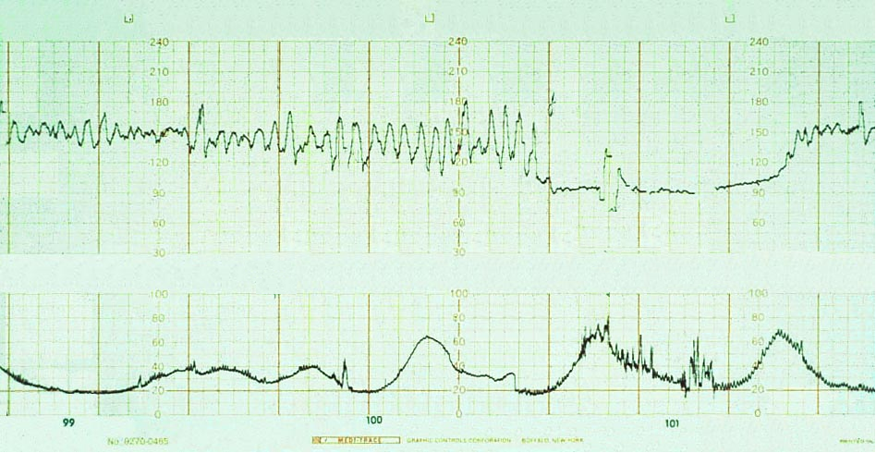
Source: Thomas Benedetti

2. Baseline Tachycardia
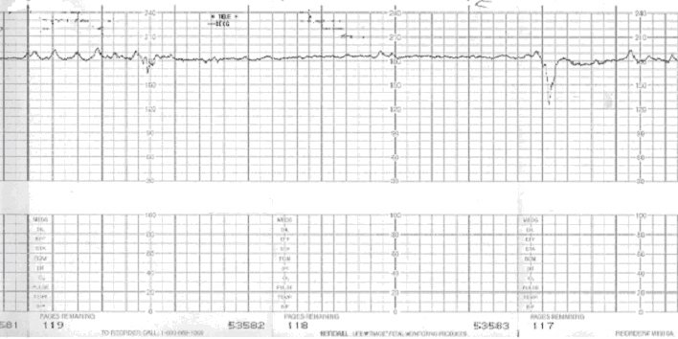Source: Katherine O’Connell

- Characteristics:
- Baseline >160 bpm over 10 minutes duration
- Represents increase in sympathetic tone or decreased parasympathetic tone
- May be caused by:
- Maternal/fetal infection/fever
- Parasympatholytic drugs (eq. Atropine)
- Hypoxemia
- Cardiac arrythmias - when the FHR is > 200 and the arrythmia is SVT

3. Baseline Bradycardia
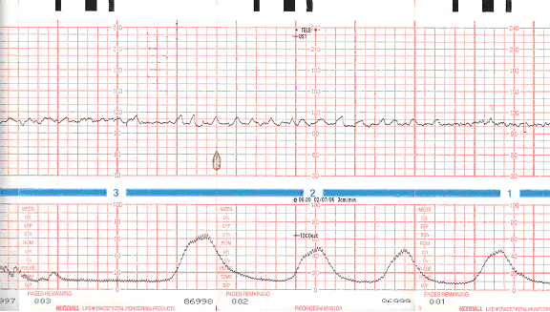

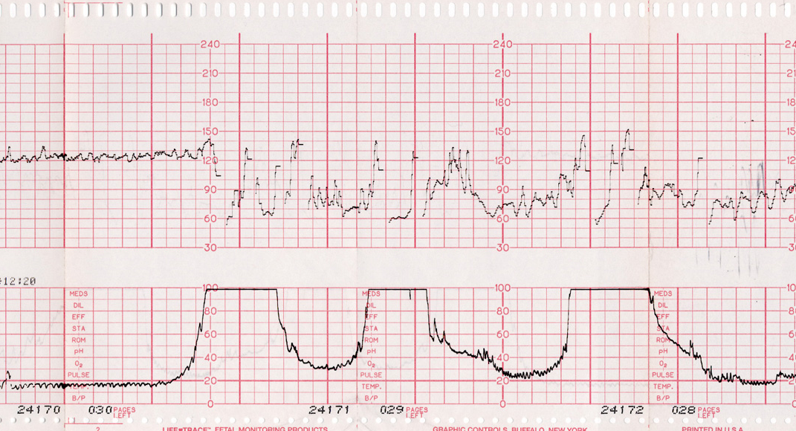
Source: Katherine O’Connell & Thomas Benedetti
• Characteristics
- Baseline < 110 bpm for > 10 minutes
- Baseline 90-110 with moderate variability generally well tolerated
- May be caused by:
- Medications, e.g., beta blockers (Propranolol, etc)
- Hypothermia
- Cardiac arrythmias – specifically congenital heart block

Hypoxia

Idiopathic
4. Accelerations
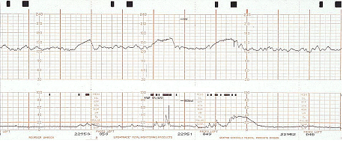
Source: Thomas Benedetti
Characteristics:
- Result from fetal sympathetic stimulation
- Visually apparent increase in FHR (onset to peak in < 30 seconds)
- Calculated from most recently determined portion of baseline
  - >/= 32 weeks gestation: > 15 beats/min above baseline > 15 seconds and < 2 minutes duration
  - <32 weeks gestation: - accelerations may be > 10 beats/minute above baseline > 10 seconds duration
- Denotes a fetus that is well oxygenated at the time acceleration occurs (ph > 7.20 with 99% probability)
- When accelerations occur with contractions, may indicate umbilical cord venous compression (baroreceptor response) but have the same reassuring significance as accelerations in the absence of contractions
- Elicit accelerations by acoustic or scalp stimulation

- Early decelerations:
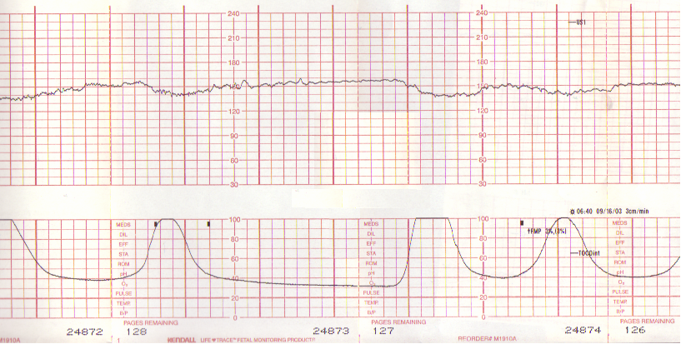

Source: Thomas Benedetti

Characteristics:
  - Visually apparent gradual decrease (onset to nadir is > 30 seconds) of the FHR and return to baseline associated with a uterine contraction
  - Calculated from the most recently determined portion of the baseline
  - Coincident in timing, with the nadir of deceleration occurring at the same time as the peak of the contraction

In MOST cases, the onset, nadir and recovery of the deceleration is coincident with the beginning, peak and ending of the contraction
  - Uncommonly seen; vagal response to fetal head compression in the active phase of labor.
  - Not associated with hypoxemia
6. Late decelerations:
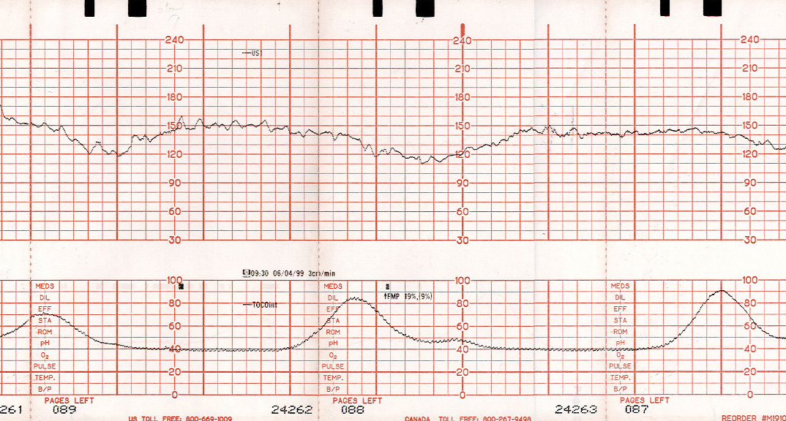
Source: Thomas Benedetti

Characteristics:
  - Visually apparent gradual decrease (onset to nadir is > 30 seconds) of the FHR and return to baseline associated with a uterine contraction
  - Calculated from the most recently determined portion of the baseline
  - Delayed in timing, with the nadir of deceleration occurring after the peak of the contraction

In MOST cases, the onset, nadir and recovery of the deceleration occur after the onset, peak and ending of the contraction. May be caused by:
    - Acute insult (eg. maternal hypotension)
    - Progressive fetal deterioration related to uteroplacental insufficiency of oxygen
    - When the fetal chemoreceptors in the aorta detect a drop in the fetal oxygen tension with the uterine contraction, the sympathetic neuronal response causes an elevation in fetal blood pressure resulting in a drop in the FHR. This complex reaction is thought to be the reason for the delay in the deceleration.

In MOST cases, late decelerations in the presence of variability indicate hypoxemia, and late decelerations in the absence of both variability and accelerations suggest hypoxia and acidosis (ph< 7.20).

7. Variable decelerations:
a. Mild-Moderate Variable Decelerations
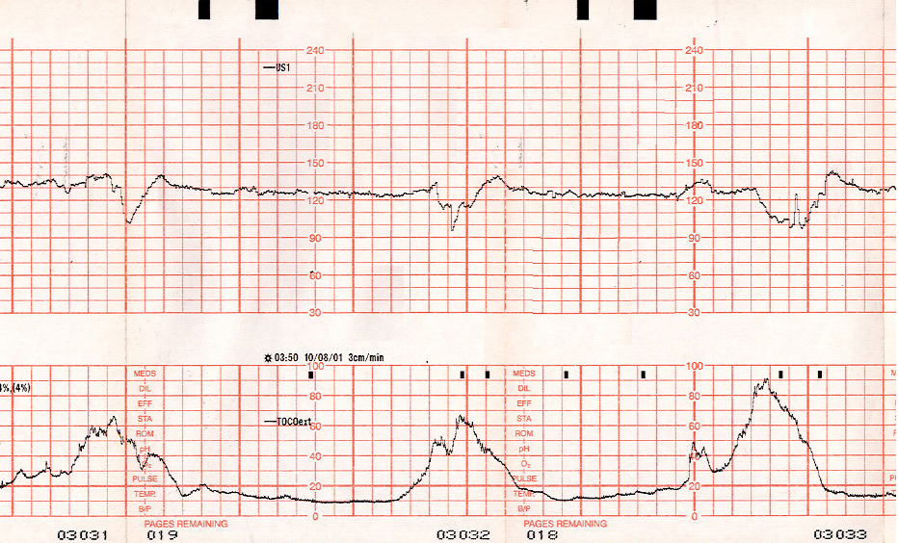
Source: Thomas Benedetti
b. Severe Variable Deceleration
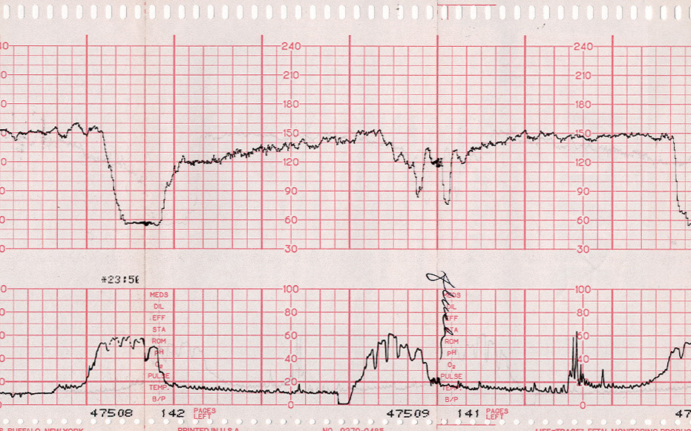
Source: Thomas Benedetti

Characteristics:
- Visually apparent abrupt decrease (onset to beginning of nadir is < 30 seconds) in FHR below baseline
Characteristics Cont’d:

- Calculated from the most recently determined portion of the baseline
- Decrease is > 15 bpm, lasting >15 seconds and <2 minutes from the onset to the return to baseline
- May have “shoulders” (transient accelerations pre- and/or post-variable)
- When variable decelerations are associated with uterine contractions, their onset, depth and duration vary with successive contractions.

The usual mechanism of variable deceleration:
- Umbilical cord occlusion leads to fetal arterial hypertension which leads to baroreceptor stimulation, which leads to vagal nerve stimulation and resultant fetal bradycardia

Severe Variable deceleration: Abrupt decrease in fetal heart rate to less than 70 bpm for less than 2 minutes

8. Prolonged Decelerations:
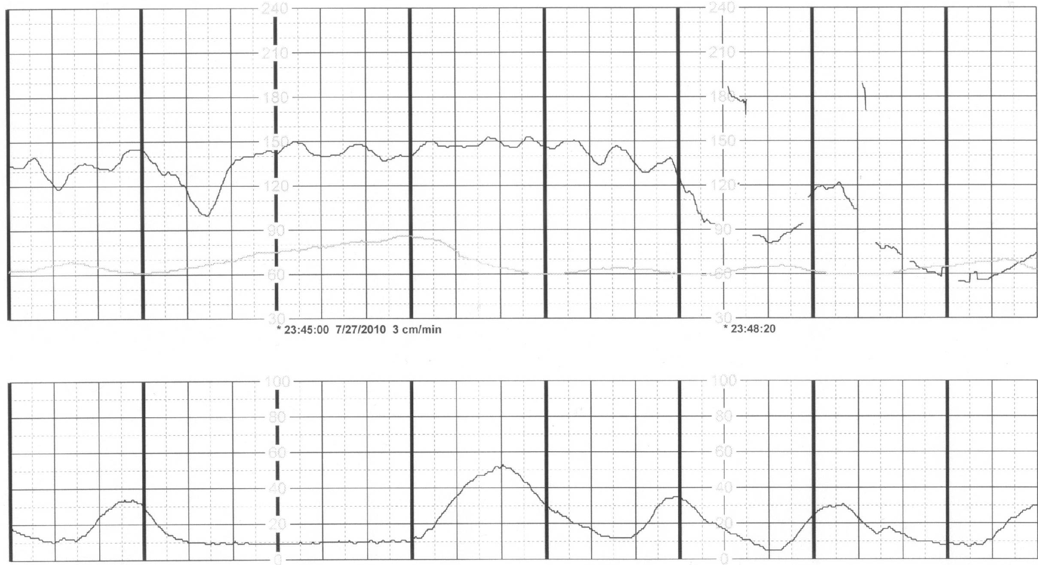

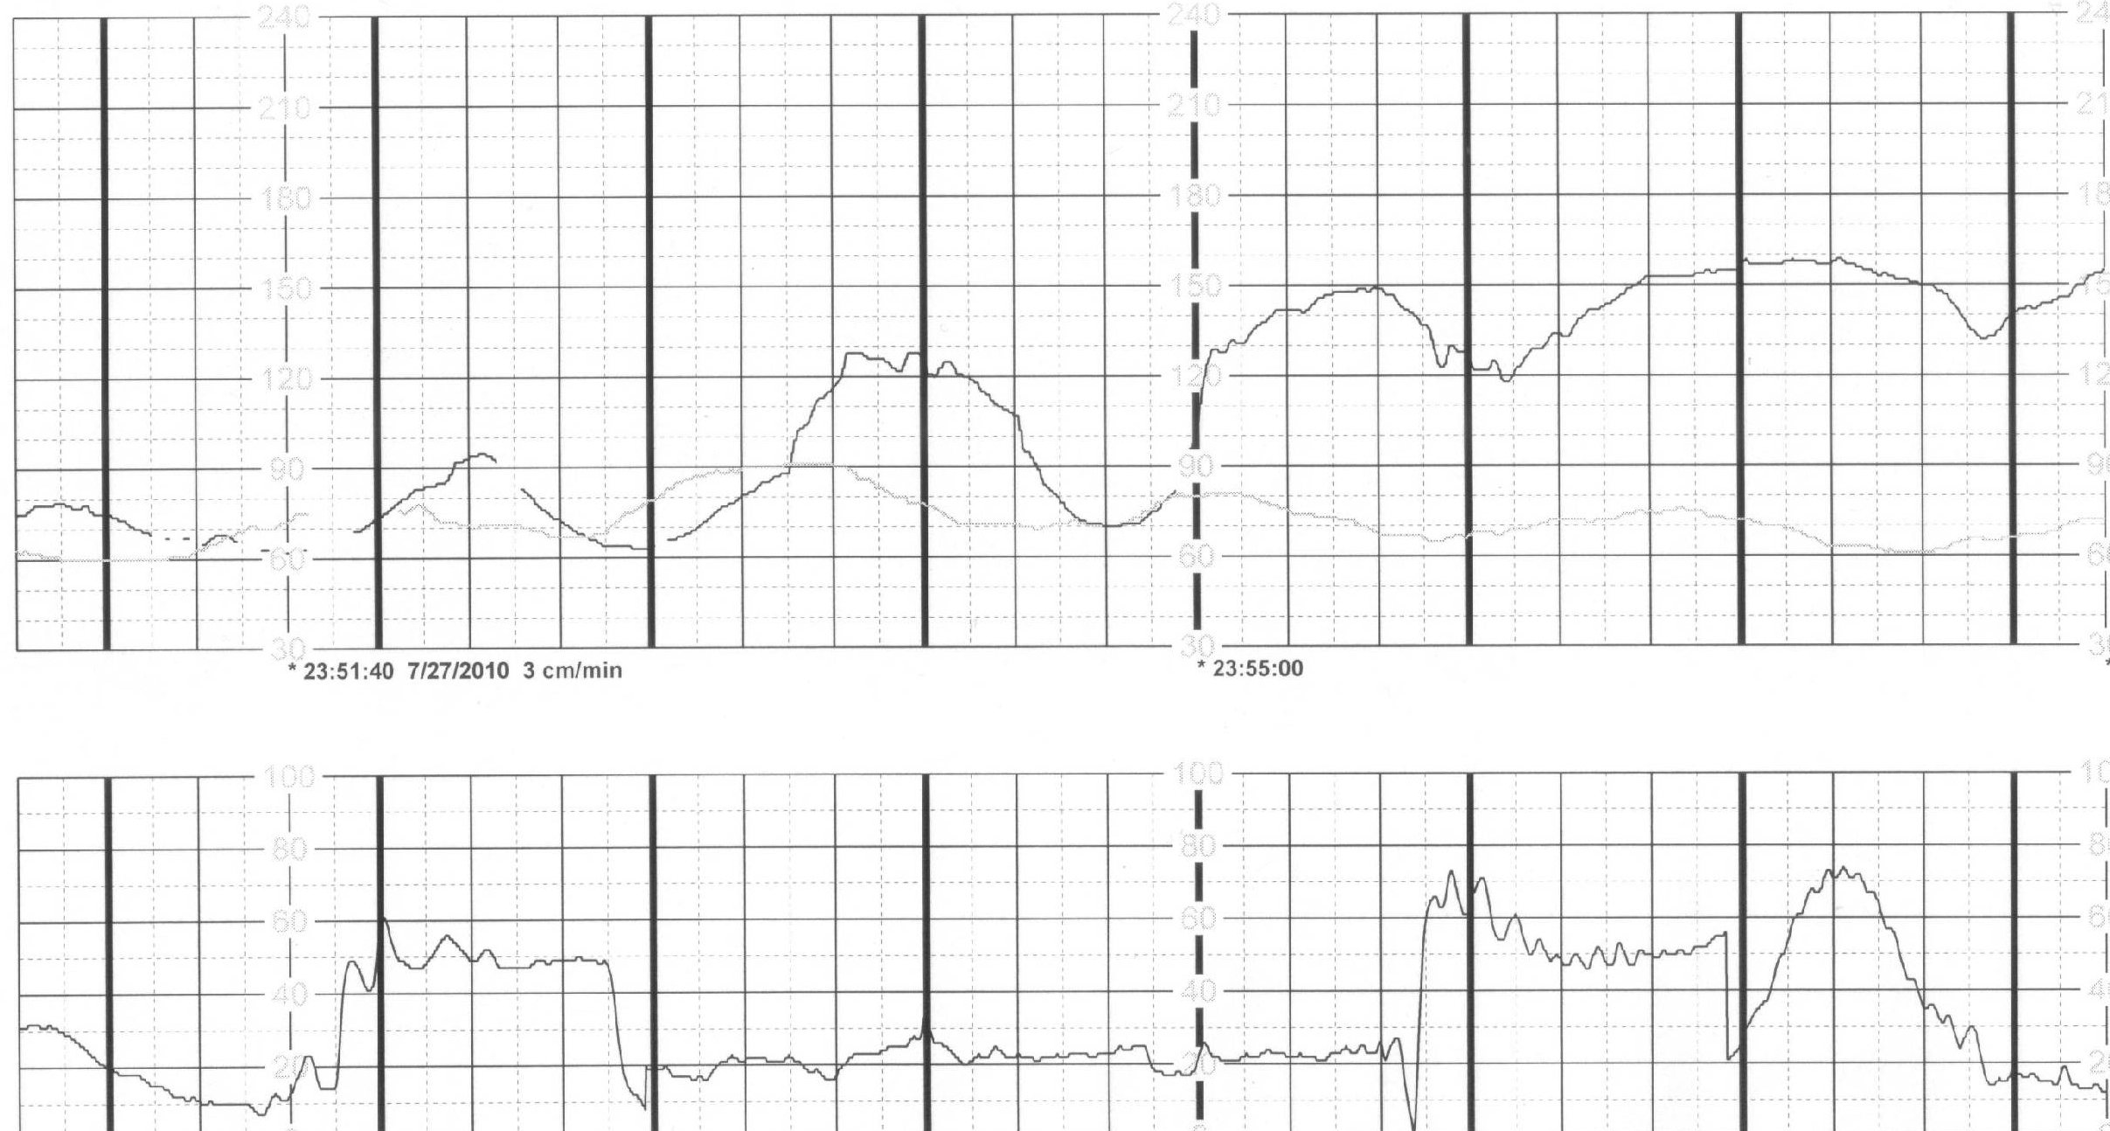
source: Katherine O’Connell

Characteristics:
- Visually apparent decrease in FHR below baseline
- Calculated from the most recently determined portion of the baseline
- Decrease is >15 bpm, lasting >2 minutes but <10 minutes from onset to return to baseline

9. Recurrent Decelerations:
Decelerations occurring with > 50% of contractions within a 20 minute segment

Interventions for Category II or III fetal heart rate tracings:
Depending on the clinical situation, efforts to resolve the abnormal FHR pattern may include, but are not limited to:
- Position change
  - Placing the mother in the lateral position relieves pressure on the vena cava, which allows venous return and improves placental perfusion
- Treatment of maternal hypotension
  - IV fluid bolus, particularly if recent epidural or spinal placement
  - Administer ephedrine sulfate 5-10 mg IV (generally per anesthesiologist)
- Discontinuance of labor stimulation by decreasing the strength and frequency of uterine contractions, especially if augmented with medication
  - Stop administration of oxytocin
  - Administer a tocolytic agent (ie. Terbutaline .25mg SQ)
- Administer oxygen via face mask at a flow rate of 10-15L/min. Improving the mother’s oxygenation improves placental perfusion (oxygen should be low on the “to do” list)
- Vaginal exam to rule out cord prolapse
  - Cord prolapse may occur with breech presentation, multiple pregnancies, unengaged presenting part with rupture of membranes, and prematurity.
- Amnioinfusion for severe variable decelerations
  - Replacing the lost amniotic fluid may alleviate the compression on the umbilical cord when contractions occur
- Alter pushing techniques
- Prepare for operative delivery if uncorrectable

If the above steps do not resolve the abnormal fetal heart rate, consideration should be given to moving the patient into an environment where delivery can be expedited.

Associations between FHR Patterns and Fetal Acidemia and/or Neonatal Vigor
- The presence of moderate variability in association with recurrent decelerations of any type and/or second stage bradycardia is 98% associated with fetal pH > 7.15 mEq/l and /or apgar score > 7 at 5 minutes
- Minimal or less fetal heart rate variability with decelerations has a 23% association with pH < 7.15 or apgar < 7 at 5 minutes

• KEY Questions to consider when assessing a fetal heart rate tracing:
- Is the patient in labor, and if so, what is the quality and frequency of her contractions?
- How dilated is the patient’s cervix? Is delivery imminent?
- What stage of labor is the patient in?
- Is the patient progressing on her labor curve?
- Is the fetal heart rate pattern Category 1? If NOT, could it be caused by:
  - maternal hypoperfusion?
  - decreased umbilical cord blood flow?
  - placental dysfunction?
  - excessive uterine activity?
                - Is the patient being augmented with oxytocin?
  - uterine rupture?
- How does the current fetal heart rate tracing compare with the initial labor or pre-labor fetal heart rate pattern?

• Documentation
Documentation of an episode/event of category II or III fetal heart rate tracings is an essential part of patient management and risk management in the event of fetal injury. Documentation includes the elements of care preceding the event, the fetal heart rate tracing throughout the event, and the response of the heart rate to interventions.

1) Documentation of category II or III fetal heart rate tracings includes, but is not limited to:
- Time of onset of event
- Stage of labor/Cervical exam
- Category of tracing
  - Decelerations
    - Type
    - Frequency/Duration
- Management steps/Interventions
- Response of FHR
- Communication with patient/other providers

2) Fetal heart rate tracing documentation elements include, but are not limited to:
- Uterine contraction frequency, duration, quality
- Baseline FHR
- Baseline variability
- Presence of accelerations
- Presence of decelerations
  - Type
  - Frequency & duration

Simulation Session Process:

1) Orientation
• Instructor provides orientation to the simulation environment
• Instructor provides overview of scenario exercise

2) The simulation session:
• Typically lasts 3-10 minutes
• Expected sequence for trainee
a. Enters room and introduces self
b. Nurse/Resident (Trainer) provides SBAR (Appendix F)
c. Evaluates mother, including vital signs
d. Evaluates the fetus, including vital signs
e. Begins management while continuing to assess the situation
f. Asks for help to be called
g. Trainee management should include:
- Position change
- Fluid bolus
- Stopping oxytocin
- Oxygen
- Trainee management could include:
- Calling for more senior help
- Tocolytic (Terbutaline, ephedrine)
- Operative vaginal delivery
- Cesarean delivery
- Notes time or asks it to be done
- Continuous communication with patient and her partner/ Disclosure if applicable

3) Trainee writes a progress note.
a. Progress note: Includes the following:
- Time, date, patient’s name
- Subjective: Patient history, Situation, Background
- Objective: Maternal and fetal vital signs, fetal heart rate tracing interpretation
- Assessment: What is happening with the fetus
- Plan: Trainee’s management of the situation and Recommended actions (i.e., move to Cesarean)

4) Debriefing session
a. Instructor will discuss experiences of each participant including concerns regarding implementing the skills learned into practice on Labor and Delivery and disclosure/communication with the patient and her partner.

Simulation Setup for:

Simulator: Obstetrics “Noelle” Simulator.

Room Setup: In the simulation center, the training room should be set up similarly to a delivery room. The simulator is on an examination table, gurney, or bed. The basic equipment listed below should be available. For in-situ testing/simulations on Labor and Delivery, the simulator should simply replace a typical patient and the room used as usual. Videotaping may be considered to assist in training and debriefing, although the data doesn’t support an advantage over traditional debriefing (ref).

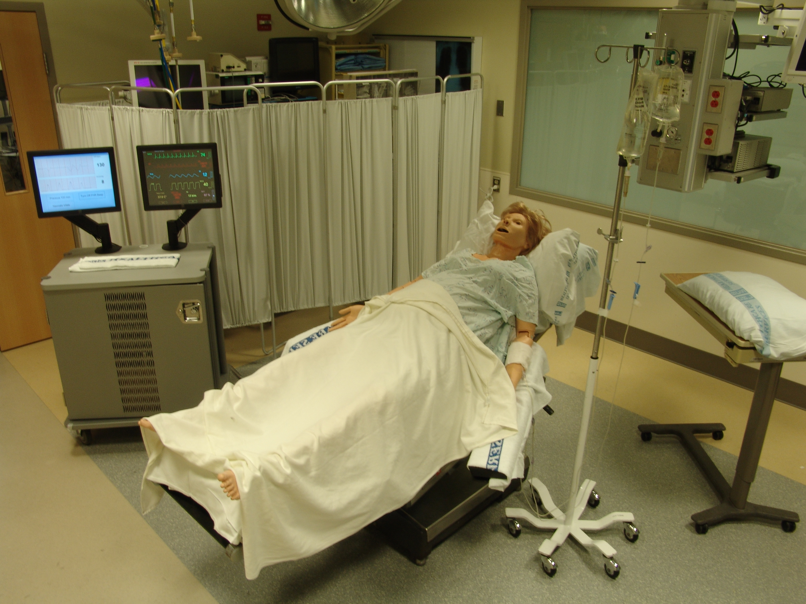

Delivery Table:
  - Table covered with drape
  - Pillow
  - Oxygen mask
  - IUPC
  - Syringe for simulated tocolytic administration
  - IV bag with labeling for induction agent (Oxytocin; Syntocinon)
  - IV bag running Normal Saline

Additional Equipment:
- Heart rate monitor
- Gloves (small, medium and large)
- 3’ length of rope for the umbilical cord (if applicable)
- Progress Note (Paper and Pens)
- Digital video camera (if you desire to record the training)
- Chronograph (may use watch with timer or even a second hand)
- Maternal Vital Signs: The vital sign software may be used to demonstrate worsening maternal status during the simulation. Incorporating this into the training helps add to the realism of the scenario as this is audible to the providers during the simulation.
- Speaker pillow to allow remote communication between “Noelle” and the trainee

Type(s) of Assessment Methods Used in This Course:

Pre-test Only | Self Evaluation Form (see appendix C)
Pre-test & Post-test | Performance Checklist (see Appendix D)
Post-test Only | Simulation Session Evaluation (see  Appendix E)
Team Debriefing (see Appendix B)

Appendix A | Simulation Scenarios
Appendix B | Debriefing Guide
Appendix C | Self-Assessment
Appendix D | Performance Checklist
Appendix E | Simulation Evaluation
Appendix F | TeamSTEPPS Glossary
Appendix G | References

Scenario Options – Brief overview

Scenarios 1 and 2 have been designed for lower-level trainees; scenarios 3 and 4 have been designed for upper-level trainees.

Scenario 1: Post-Dates Induction with Prolonged Deceleration
The trainee is asked to evaluate a patient on the request of the nurse because the fetal heart rate tracing shows 10 minutes of variable decelerations followed by a prolonged deceleration. Uncomplicated pregnancy and labor.
Outcome: Resolution of decelerations if managed correctly

Scenario 2: Uterine Tachysystole Due to Oxytocin Dosing
The trainee is called emergently to a delivery room by the nurse because the patient is complaining of increasingly painful contractions. Uncomplicated pregnancy and labor.
Outcome: Resolution of deceleration if managed correctly

Scenario 3: Rupture of Membranes, Cord Prolapse
A patient has arrived in the Labor and Delivery triage room. She says her “water” broke as she was going into the exam room. She is a teenage G1 who had no prenatal care.
Outcome: Zero-minute Cesarean for overt umbilical cord prolapse. (Zero-minute is defined as a Cesarean done as quickly as possible)

Scenario 4: Maternal Hypotension
The trainee is asked to re-evaluate a patient on the request of the nurse because she is concerned about the fetal tracing. The patient just received her epidural and is comfortable. Pregnancy complicated by preeclampsia at term leading to the induction.
Outcome: Zero-minute Cesarean for uncorrectable fetal bradycardia
Scenarios 1 and 2 have been designed for lower-level trainees; scenarios 3 and 4 have been designed for upper-level trainees.

SCENARIO 1: Post-Dates Induction

Setting:
OR1 because L&D is “Full”

Note to instructors: This is in order to avoid the “lets move to the back and continue monitoring” management plan. The trainee needs to call the Cesarean or not.

Simulation introduction:
“You are being called to OR1 at 2am on the request of the nurse to evaluate a nurse midwife patient that recently started an induction of labor. The nurse is concerned about the fetal heart tracing. The nurse midwife is on her way in.”

SBAR provided by trainer (Playing role of nurse)
Situation
“Ms. XXX has had 10 minutes of variable decelerations and is now having a prolonged deceleration”
Background
“28 yo primipara at 41 weeks and 2 days who presented for induction of labor for post dates. Pregnancy was uncomplicated. She entered active phase 1 hour ago
Assessment
“The baby is having a prolonged deceleration x3 minutes”
Recommendation
“I need your help with what to do”

Resolution: (The scenario ends when the trainee)
- Changes the maternal position, administers IV fluids and Oxygen, and stops the administration of oxytocin;
  - Allow for resolution of the deceleration before completing scenario
- Calls for a Caesarean;
- Does not effectively manage the scenario and the trainer calls an end because the fetal heart rate has uncorrectable bradycardia.

Answers to Common questions (Q)/exam requests (E)
General
Q: “Call pediatrics/my attending/ my senior resident?” – A: “They are on their way”
E: “I want to check her cervix?” – A: “you examine her cervix and it is 6cm dilated, completely effaced and her station is +1”
Q: “What was her last exam?” – A: “One hour ago she was 5cm and 60% effaced, +1 station”
Q: “Let’s move her to her side/ change her position” – A: Assist the trainee or move the patient with her spouse’s assistance
Q: “Please give her some oxygen at 10 L/min”- A: “Yes” and provide face mask connected to O2.
Q: “Does she have IV fluid running?/ at what rate?/ give her a bolus” – A: “Yes”/ “125cc/hr”/ “Fluid wide open” – if asked to do so
Q: “Can you give her X?” – A: “X is given” – repeat back the drug, dose and route. If the nurse is also a trainee, and the dosing is incorrect, they should question the other trainee.
Q: “Is she on oxytocin?” – A: “Yes,” but do not suggest it should be stopped.
Q: “What are her vital signs?” – A: “They have been normal since admission (need to give actual numbers,” and refer them to the monitor.
Q: “Is this an internal lead or IUPC?” – A: “No, but the tracings have been accurate and mom has an O2 sat on”
Q: “Let's move to Cesarean?” – This is NOT the correct management and effectively ends the scenario although if chosen, the trainee should get verbal consent from the patient and provide an explanation to the patient and spouse of the reason.

Scenario 1 simulation control instructions:
• Prior to trainee entering the room
  - Program 10 minutes of tracing with baseline FHR of 140 & moderate variability with 30 second contractions every 2 minutes; then 10 minutes of baseline FHR of 140, no variability and variable decelerations.
  - Turn on maternal vital signs
  - Set up simulator mannequin
    - Actress providing voice ready with microphone and speakers working
    - Place toco and FHR monitors
    - IV in place
    - oxytocin on
    - Oxygen face mask ready for use
  - Actor playing dad ready
  - Trainer playing nurse ready
  - Cameras for video recording properly placed
  - Video recorder ready to record
  - Self-evaluation ready for trainee to fill out
  - Management note ready for trainee to fill out
  - If monitoring trainees’ heart rates, have heart rate monitor and ECG leads ready
  - If using pretest, ensure that it has been completed and turned in

• As trainee enters room:
1) Start prolonged deceleration to ~60 bpm
2) Respond to Trainee requests as directed above
3) FHR tracing should completely resolve if
- Change in patient position – preferably Left lateral
- IV fluid bolus
- Discontinue Pitocin
- Administer oxygen
4) FHR tracing can improve if only 2 steps are done, however the variability should remain absent
3) Initiate uncorrectable bradycardia if trainee has not treated the problem at all or made a definitive plan (Cesarean) within 5 minutes.

SCENARIO 2: Uterine Tachysystole

Setting:
OR1 because L&D is “Full”

Note to instructors: This is in order to avoid the “lets move to the back and continue monitoring” management plan. The trainee needs to call the Cesarean or not.

Simulation introduction:
“You are being called to OR1 to evaluate a family medicine patient on the request of the Family Medicine intern because she/he is concerned about the fetal heart tracing.”

SBAR provided by trainer (Playing role of intern)
Situation
“Ms. XXX has had 10 minutes of variable decelerations and is now having a prolonged deceleration.”
Background
“22 yo primipara at 42 weeks and 0 days who presented for induction of labor for post dates. Pregnancy was uncomplicated. She entered active phase 1 hour ago and her cervix has been dilating appropriately. Her contractions have become increasingly uncomfortable and she is now thinking about an epidural although she had hoped to go natural.”
Assessment
“The baby isn’t tolerating labor.”
Recommendation
“I think she may need a cesarean.”

Resolution: (The scenario ends when the trainee)
- Stops the administration of pitocin (This is the key intervention)
  - Should also: Change the maternal position, administer IV fluids and Oxygen
  - Should give tocolytic (e.g., Terbutaline)
  - Allow for resolution of the deceleration before completing scenario
- Calls for a Caesarean - Inappropriate
- Does not effectively manage the scenario and the trainer calls an end because the fetal heart rate has a terminal bradycardia. This should happen if the trainee does not discontinue the pitocin.

Answers to Common questions (Q)/exam requests (E)
General
Q: “Call pediatrics/my attending/my senior resident?” – A: “They are on their way.”
E: “I want to check her cervix?” – A: “you examine her cervix and it is 6cm dilated, completely effaced and her station is +1.”
Q: “What was her last exam?” – A: “One hour ago she was 5cm and complete, +1 station.”
Q: “Let’s move her on her side/change her position” – A: Assist the trainee or move the patient with her spouse’s assistance.”
Q: “Can we give her some oxygen”- A: “Yes,” and provide face mask connected to O2.
Q: “Does she have IV fluid running?/at what rate?/give her a bolus” – A: “Yes”/“125cc/hr”/ “Fluid wide open” – if asked to do so.
Q: “Can you give her X?” – A: “X is given” – repeat back the drug, dose and route. If the nurse is also a trainee, and the dosing is incorrect, they should question the other trainee.
Q: “Is she on pitocin?” – A: “Yes” but do not suggest it should be stopped.
Q: “What are her vital signs” – A: “They have been normal since admission” and refer them to the monitor.
Q: “Is this scalp electrode or IUPC” – A: No, but the tracings have been accurate and not confused with the mother’s heart rate.”
Q: “Let's move to Cesarean?” – This is NOT the correct management and effectively ends the scenario although if chosen, the trainee should get verbal consent from the patient and provide an explanation to the patient and spouse of the reason.

Scenario 2 simulation control instructions:
• Prior to trainee entering the room
  - Program 10 minutes of tracing with baseline FHR of 140 and moderate variability with 30 second contractions every 2 minutes; then 10 minutes of baseline FHR of 140, minimal variability with 30 second contractions every 2 minutes.
  - Turn on maternal vital signs
  - Set up simulator mannequin
    - Actress providing voice ready with microphone and speakers working
    - Place toco and FHR monitors
    - IV in place
    - Pitocin on
    - Oxygen face mask ready for use
  - Actor playing dad ready
  - Trainer playing nurse ready
  - Cameras for video recording properly placed
  - Video recorder ready to record
  - Self-evaluation ready for trainee to fill out
  - Management note ready for trainee to fill out
  - If monitoring trainees’ heart rates, have heart rate monitor and ECG leads ready
  - If using pretest, ensure that it has been completed and turned in

• As trainee enters room:
- Start prolonged deceleration and change contraction length to 60 seconds. Contraction pattern prior to entry should show contractions Q2 min
2) Respond to trainee requests as directed above
3) FHR tracing should completely resolve only if the pitocin is discontinued
4) Initiate terminal bradycardia if trainee has not discontinued the pitocin within 8 minutes. To imitate reality, build to terminal bradycardia by changing contraction frequency from Q2min, to Q1.5min for 5 min then Q1min for 5 min

SCENARIO 3: Cord Prolapse

Setting:
L&D Triage

Simulation introduction:
“You are being called to the triage room to evaluate a woman who may have just ruptured her membranes”

SBAR provided by nurse
Situation
“As Ms. XXX walked into the triage room she had a gush of fluid with a contraction. We’re just getting her on the monitor now.”
Background
17 yo gravida 1 who presents at approximately 35 weeks having uterine contractions of increased severity for 10 hours before being seen. Due to social disarray she has not had much prenatal care, although a second trimester ultrasound dated her and noted a fundal placenta.
Assessment
I’m concerned that we know nothing about her.
Recommendation
She needs labs, an ultrasound and an exam?

Resolution: (The scenario ends when the trainee)
1. Calls for a zero-minute Cesarean & maintains head support
2. Does not recognize cord prolapse and the trainer calls an end because the fetal heart rate has a terminal bradycardia and none of the traditional maneuvers have worked.

Answers to Common questions (Q)/exam requests (E)
General
Q: “Call pediatrics/my attending/my senior resident?” – A: They are on their way
E: “I want to check your cervix?” – Help set the patient up for a cervical exam
E: “I want to do a speculum exam” – A: “The exam shows a pool of fluid in the vaginal vault, the cervix appears dilated to 4 and the head and possibly the umbilical cord are visible”
Q: “Lets move her on her side/change her position” – A: Assist the trainee or move the patient with her spouse’s assistance
Q: “Can we give her some oxygen”- A: “Yes” and provide face mask connected to O2.
Q: “Does she have IV fluid running?/at what rate?/give her a bolus” – A: “Yes”/“125cc/hr”/ “Fluid wide open” – if asked to do so
Q: “Can you give her X?” – A: “X is given” – repeat back the drug, dose and route. If the nurse is also a trainee, and the dosing is incorrect, they should question the other trainee.
Q: “What are her vital signs” – A: “B/P: 120/70; HR 90; Temp: 38.5˚”
Q: “I would like to put on internal monitors” – A: “OK but the tracing is accurate”
Q: “Let's move to Cesarean?” – This is the correct management if the trainee recognizes and maintains support of the fetal head. The trainee should get verbal consent from the patient and provide an explanation to the patient and spouse of the reason. At this point, anesthesia, and additional nursing and resident care should arrive. The trainee should maintain the leadership role, effectively directing the staff to assist in getting the patient to the OR.

Scenario 3 simulation control instructions:
• Prior to trainee entering the room
- Program 15 seconds of tracing with baseline FHR of 140 and moderate variability, but immediately begin to bring the tracing down, mimicking a prolonged deceleration. The heart rate should drop from 140 to 60 over ~1 minute and should not recover. Contractions should be Q2 minute and 60 seconds long
- Turn on maternal vital signs
- Set up simulator mannequin
    - Actress providing voice ready with microphone and speakers working
    - Place toco and FHR monitors
    - IV in place
    - Pitocin on
    - Oxygen face mask ready for use
- Actor playing dad ready
- Trainer playing nurse ready
- Cameras for video recording properly placed
- Video recorder ready to record
- Self-evaluation ready for trainee to fill out
- Management note ready for trainee to fill out
- If monitoring trainees’ heart rates, have heart rate monitor and ECG leads ready
- If using pretest, ensure that it has been completed and turned in

• As trainee enters room:
1) Continue prolonged deceleration to base of 60 with no variability
2) Respond to trainee requests as directed above
3) FHR tracing should improve only if the cord prolapse is identified, the fetal head is supported, and the trainee asks for an immediate cesarean delivery
4) If the trainee has not identified the cord prolapse within 4 minutes, terminate the simulation

SCENARIO 4: Maternal Hypotension

Setting: LDR7

Simulation introduction:
You are being is asked to evaluate an R1 patient admitted last night because the nurse is concerned about the fetal tracing.
Outcome: Zero-minute cesarean for terminal bradycardia

SBAR provided by nurse (Trainer playing part of nurse)
Situation
The patient is comfortable now with an epidural but she is starting to have some decels.
Background
42 yo G4 P2 at 38 weeks and 3 days who presented for induction of labor for cholestasis. Pregnancy was complicated by patient smoking approximately 4 cigarettes a day. Lungs are mature. Patient has type II diabetes and fibromyalgia. Mild IUGR was noted on the first and second trimester ultrasounds. She is comfortable now that she has her epidural
Assessment
She SROM’ed about 2 hours ago and now the umbilical cord is getting squeezed a bit with the contractions
Recommendation
Let’s change her position and give her an IUPC and everything will be all right.

Resolution: (The scenario ends when the trainee)

1. The trainee should:
a. administer IV fluid bolus of at least 500cc (This is the key intervention)
b. Stop the administration of pitocin
c. Change the maternal position
d. Inquire about maternal blood pressure
e. Call for anesthesia, additional help
2. Calls for a Zero-minute Cesarean - inappropriate
3. Does not effectively manage the scenario and the trainer calls an end because the fetal heart rate has a terminal bradycardia. This should happen if the trainee does not call for a Cesarean in a timely fashion (3-4 mintues).

Answers to Common questions (Q)/exam requests (E)
General
Q: “Call pediatrics/my attending/my senior resident?” – A: They are on their way
E: “I want to check her cervix?” – A: “you examine her cervix and it is 6cm dilated, completely effaced and her station is +1”
Q: “What was her last exam?” – A: “One hour ago she was 5cm and 60% effaced, +1 station”
Q: “Let’s move her on her side/ change her position” – A: Assist the trainee or move the patient with her spouse’s assistance
Q: “Can we give her some oxygen”- A: “Yes” and provide face mask connected to O2.
Q: “Does she have IV fluid running?/at what rate?/give her a bolus of X” – A: “Yes”/ “125cc/hr”/“Fluid wide open” – if asked to do so
Q: “Can you give her X?” – A: “X is given” – repeat back the drug, dose and route. If the nurse is also a trainee and the dosing is incorrect they should question the other trainee.
Q: “Is she on pitocin?” – A: “Yes” but do not suggest it should be stopped.
Q: “What are her vital signs” – A: “They have been normal since admission” and refer them to the monitor. The only abnormal VS should be a low BP – ~100/50.
Q: “I would like to put on internal monitors” – A: “OK but the tracing is accurate”
Q: “I would like to put in an IUPC” – A: “OK, it’s in”. Trainee should say how to run the IUPC.
Q: “Let's move to Cesarean?” – This is NOT the correct thing to do. Trainee should get verbal consent from the patient and provide an explanation to the patient and spouse of the reason. At this point, anesthesia, and additional nursing and resident care should arrive. The trainee should maintain the leadership role, effectively directing the staff to assist in getting the patient to the OR.

Scenario 4 simulation control instructions:
• Prior to trainee entering the room
- Program 10 minutes of tracing with baseline FHR of 140 & moderate variability with 30 second contractions every 3 minutes; then 10 minutes of baseline FHR of 140, no variability and with 30 second contractions every 2 minutes.
- Turn on maternal vital signs
- Set up simulator mannequin
    - Actress providing voice ready with microphone and speakers working
    - Place toco and FHR monitors
    - IV in place
    - Pitocin on
    - Oxygen face mask ready for use
- Actor playing dad ready
- Trainer playing nurse ready
- Cameras for video recording properly placed
- Video recorder ready to record
- Self-evaluation ready for trainee to fill out
- Management note ready for trainee to fill out
- If monitoring trainees’ heart rates, have heart rate monitor and ECG leads ready
- If using pretest, ensure that it has been completed and turned in

• As trainee enters room:
1) Start prolonged decelerations and change contraction length to 60 seconds
2) Respond to trainee requests as directed above
3) FHR tracing should change:
- Contractions stop only if the pitocin is discontinued.
- Decelerations should resolve with fluid bolus after a few minutes.
4) Initiate terminal bradycardia if trainee has not provided a fluid bolus within 8 minutes

“Simulation creates the opportunity to debrief.”

Simulation creates the opportunity to examine our medical management, team dynamics, and communication skills. It allows us to talk about the challenges we face in a safe environment and improve the way we care for patients as a team.

For more extensive instruction on optimal debriefing please refer to the references.

Debriefing Strategy
- The Basic Assumption for the debriefing is:
  - “We believe that everyone participating in the simulation scenario is intelligent, well-trained, cares about doing their best, and wants to improve”.
  - Method of debriefing should be based on learning objectives and targeted to analyze critical actions and the impact of experience on the participants
- General Facilitator Goals:
  - Try to facilitate the TEAM’s discussion or individual self reflection if one-on-one debrief (avoid dominating the conversation)
  - Ask open-ended questions (avoid yes/no questions)
  - Discuss the performance (not the individual)

Framework for debriefing:
Each debrief should consist of:
  - Introduction
  - Discussion of Medical Management
  - Summary

- Introduction
This “sets the stage” for debriefing and creates expectations.
What you might say:
    - “This is an opportunity to reflect and learn, improve our medical care, team work, and communication.”
    - “Everyone may ask questions and share their feelings.”
    - “Once you leave this session, we encourage open discussions of the concepts you learn, but ask you to keep specifics about the scenario and individual’s performances within these walls.”

- Medical Management
This portion of the discussion focuses on the medical aspects of the case. It’s usually more comfortable to begin with these “facts”.
- Reactions
  - Clear the air and set the stage for discussion
  - Facts
- What happened?
  - Participants often want to know "the answer"
  - Stick to the facts
- How did you feel about that?
  - Accept expressions of feelings
    - “Acknowledge” is not the same as “agree”
    - Try to mirror feelings rather than evaluate them
    - Don't tell participants "that's OK" when it may not be
  - Give perspective if participant feelings are hurt, e.g.:
    - I've seen this a dozen times and that happens nearly every time… or,
    - I've made the same mistake… or,
    - We all make mistakes and this is a good place to learn from them… or,
    - Remind them of the Basic Assumption (above) and say that we’ll work together to figure out what happened…

Understanding
Remember to use Advocacy-Inquiry: be curious!
        - Exploring
        - Applying
        - Generalizing

Exploring
        - What were you thinking at the time?
        - It looked to me like…
(Use this to discuss some error you observed and would like to find out why the trainee chose a particular course of action)
        - How do you account for that?
        - Why did that happen?
        - What led to it? What next?

Applying
        - What drug or procedure or behavior might be best?
        - Have you ever done this clinically?
        - How might this be reflected in your clinical practice?

- Generalizing
        - Have you ever seen anything similar to this in your practice?
        - Are there analogies to the clinical world?
        - What can be done in a similar situation?
- Overview
        - How did this scenario go in terms of team work and communication?
        - How did this scenario go in terms of patient safety?
        - How could this training scenario be improved?

3) Summarizing
- This is your opportunity to ensure the key learning points are highlighted
- Try to choose approximately 3 take-home medical management and team management points.
Medical management examples:
        - This was a case of a category III fetal heart rate tracing in a laboring woman.
        - Signs of category III tracings can include absent variability, recurrent late or variable decelerations, bradycardia, and a sinusoidal pattern.
        - Recognize fetal status and begin algorithm for improvement

Specific Teaching Points to discuss in debriefing:

Assessment/Communication

- Introduce yourself to everyone in the room

- Don’t ignore the patient – inform them about what is happening during the process

- Be sure to discuss the events with the patient and partner at the appropriate time without using medical jargon

- Above all remain calm!

Clinical Care
- Knowledge of the differential and management of category II or III fetal heart rate tracings must be ingrained so that panic cannot overwhelm one’s ability

- Take your time to prepare and resolve the problem

TEAMSTEPPS COMMUNICATION

- If support you requested arrives, provide an SBAR

- Debrief with the involved delivery staff after the event:
  - How did everyone feel about what just occurred?
  - What went well?
  - What could have been done better?
    - Be sure to include pediatrics if appropriate.
  - Briefly discuss chart documentation.

Identification and Management
 | Strongly  Disagree | Disagree | Neutral | Agree | Strongly  Agree | N/A
- I was able to evaluate the situation correctly. | 1 | 2 | 3 | 4 | 5 | N/A
- I was able to implement the correct management. | 1 | 2 | 3 | 4 | 5 | N/A
- My management was timely. | 1 | 2 | 3 | 4 | 5 | N/A
- I was able to determine the need for further assistance. | 1 | 2 | 3 | 4 | 5 | N/A
Interpersonal and Communication Skills
 | Strongly  Disagree | Disagree | Neutral | Agree | Strongly  Agree | N/A
- I acknowledged the nurse when I arrived on scene. | 1 | 2 | 3 | 4 | 5 | N/A
- I communicated effectively with the delivery staff, using TeamSTEPPS principles and language. | 1 | 2 | 3 | 4 | 5 | N/A
- I communicated effectively with the patient. | 1 | 2 | 3 | 4 | 5 | N/A
- I communicated effectively with the patient’s partner. | 1 | 2 | 3 | 4 | 5 | N/A
- I was honest, accurate, and avoided jargon when communicating with the patient and her partner. | 1 | 2 | 3 | 4 | 5 | N/A
- I properly documented the fetal heart rate event. | 1 | 2 | 3 | 4 | 5 | N/A

My strengths during the management of the scenario:

Areas that I could improve:

SCENARIO 1 (Placental insufficiency) PERFORMANCE CHECKLIST

Name/Year___________________ __ Examiner_________ Date__________ Simulation: ______
- Trainee Situation Assessment
- Introduces themselves to patient and family Yes
- Acknowledges nurse/staff in room, asks for SBAR Yes
- Assess fetal status – Fetal Heart Rate Tracing Yes
- Diagnoses category II or III fetal heart rate tracing with probable cause Yes
- Calls for help Yes
  - Extra nursing Yes
  - Senior resident/Attending Yes
  - Anesthesia Yes
  - Pediatrics Yes
- Examines patient Yes
- Trainee Management
- Maternal Position Change Yes
- IV fluid bolus Yes
- Discontinue Pitocin Yes
- Supplemental Oxygen Yes
- Administer terbutaline Yes
- Correct route/dose – 250 MICROgrams Yes
- Call for “zero-minute” cesarean section (Incorrect) Yes

3. Patient Communication
- Provide a statement explaining what is going on Yes
- Uses understandable language Yes
- Check for patient/family’s understanding Yes
- Reassures the patient Yes
- Use of positive or negative non-verbal responses Yes
  - Pos: Touch, moving in Yes
  - Neg: moving back, crossing arms Yes
- Express clinical emotion/apologize for change in patient’s expectations Yes
- Complete summary provided to mother Yes
4. Documentation
- Time of onset of event Yes
- Stage of labor/Cervical exam Yes/Yes
- Category of fetal heart rate tracing Yes
- Decelerations Yes
- Type Yes
- Frequency/Duration Yes/Yes
- Management steps Yes
- Response of FHR tracing Yes

5. Global assessment of performance
Poor Excellent
1 2 3 4 5

SCENARIO 2 (Hyperstimulation) PERFORMANCE CHECKLIST

Name/Year___________________ __ Examiner_________ Date__________ Simulation: ______
- Trainee Situation Assessment
- Introduces themselves to patient and family Yes
- Acknowledges nurse/staff in room, asks for SBAR Yes
- Assess fetal status – Fetal Heart Rate Tracing Yes
- Diagnoses category II or III fetal heart rate tracing with probable cause Yes
- Calls for help Yes
  - Extra nursing Yes
  - Senior resident/Attending Yes
  - Anesthesia Yes
  - Pediatrics Yes
- Examines patient Yes
- Trainee Management Discontinue Pitocin (Key Managemet choice) Yes
- Supplemental Oxygen Yes
- Maternal Position Change Yes
- IV fluid bolus Yes
- Administer terbutaline Yes
- Correct route/dose – 250 MICROgrams Yes
- Call for “zero-minute” cesarean section (Incorrect) Yes
3. Patient Communication
- Provide a statement explaining what is going on Yes
- Uses understandable language Yes
- Check for patient/family’s understanding Yes
- Reassures the patient Yes
- Use of positive or negative non-verbal responses Yes
  - Pos: Touch, moving in Yes
  - Neg: moving back, crossing arms Yes
- Express clinical emotion/apologize for change in patient’s expectations Yes
- Complete summary provided to mother Yes
4. Documentation
- Time of onset of event Yes
- Stage of labor/Cervical exam Yes/Yes
- Category of fetal heart rate tracing Yes
- Decelerations Yes
- Type Yes
- Frequency/Duration Yes/Yes
- Management steps Yes
- Response of FHR tracing Yes

5. Global assessment of performance
Poor Excellent
1 2 3 4 5
SCENARIO 3 (Cord Prolapse) PERFORMANCE CHECKLIST

Name/Year___________________ __ Examiner_________ Date__________ Simulation: ______
- Trainee Situation Assessment
- Introduces themselves to patient Yes
- Acknowledges nurse/staff in room, asks for SBAR Yes
- Assess fetal status – Fetal Heart Rate Tracing Yes
- Diagnoses category II or III fetal heart rate tracing with probable cause Yes
- Calls for help if necessary Yes
  - Extra nursing Yes
  - Senior resident Yes
  - Anesthesia Yes
  - Pediatrics Yes
- Examines patient Yes
- Trainee Management
- Call for “zero-minute” cesarean section (THIS IS CORRECT) Yes
- Maternal Position change to all fours (THIS IS CORRECT) Yes
- Administer terbutaline Yes
- Correct route/dose – 250 MICROgrams Yes
- IV fluid bolus Yes
- Supplemental Oxygen Yes
- Incorrect choices:
Amnioinfusion Yes
Internal leads
- When help arrives, conducts “Brief” in the SBAR format. Yes
Assigns roles to assistants to facilitate transfer to OR
3. Patient Communication
- Provide a statement explaining what is going on Yes
- Use understandable language Yes
- Check for family’s understanding Yes
- Reassure the patient Yes
- Be aware of positive and negative non-verbal responses Yes
  - Pos: Touch, moving in Yes
  - Neg: moving back, crossing arms Yes
- Express clinical emotion/apologize for change in patient’s expectations Yes
- Assure follow-up with family Yes
4. Documentation
- Time of onset of event Yes
- Stage of labor/Cervical exam Yes/Yes
- Decelerations Yes
- Type Yes
- Frequency/Duration Yes/Yes
- Management steps Yes
- Response of FHR tracing Yes
- Complete summary provided to mother Yes

5. Global assessment of performance
Poor Excellent
1 2 3 4 5

SCENARIO 4 (Hypotension) PERFORMANCE CHECKLIST

Name/Year___________________ __ Examiner_________ Date__________ Simulation: ______
- Trainee Situation Assessment
- Introduces themselves to patient Yes
- Acknowledges nurse/staff in room, asks for SBAR Yes
- Assess fetal status – Fetal Heart Rate Tracing Yes
- Diagnoses category II or III fetal heart rate tracing with probable cause Yes
- Calls for help if necessary Yes
  - Extra nursing Yes
  - Senior resident Yes
  - Anesthesia Yes
  - Pediatrics Yes
- Examines patient Yes
- Trainee Management
- Maternal Position Change Yes
- IV fluid bolus Yes
- Supplemental Oxygen Yes
- Discontinue Pitocin Yes
- Administer terbutaline Yes
Correct route/dose – 250 MICROgrams Yes
- Incorrect choices:
Amnioinfusion Yes
Internal leads
- Call for “zero-minute” cesarean section (Correct after above) Yes
- When help arrives, conducts “Brief” in the SBAR format. Yes
Assigns roles to assistants to facilitate transfer to OR
3. Patient Communication
- Provide a statement explaining what is going on Yes
- Use understandable language Yes
- Check for family’s understanding Yes
- Reassure the patient Yes
- Be aware of positive and negative non-verbal responses Yes
  - Pos: Touch, moving in Yes
  - Neg: moving back, crossing arms Yes
- Express clinical emotion/apologize for change in patient’s expectations Yes
- Assure follow-up with family Yes
4. Documentation
- Time of onset of event Yes
- Stage of labor/Cervical exam Yes/Yes
- Decelerations Yes
- Type Yes
- Frequency/Duration Yes/Yes
- Management steps Yes
- Response of FHR tracing Yes
- Complete summary provided to mother Yes

5. Global assessment of performance
Poor Excellent
1 2 3 4 5

This checklist identifies core medical management skills. It’s hard to discuss more than 3 of these during one debriefing session. We recommend selecting 2-4 of these issues to focus on.

Obtaining significant OB history □ Done Well □ Needs Work

Specific comments: ____________________________________________________________
____________________________________________________________________________
____________________________________________________________________________

What’s in a SAMPLE history? Rupture of membranes, location of placenta, gestational age, stage of labor?

Recognition of category II or III fetal heart rate tracing □ Done Well □ Needs Work

Specific comments: ____________________________________________________________
____________________________________________________________________________
____________________________________________________________________________

Discussion Points: What signs of category II or III fetal heart rate tracings did you see? What would have helped you identify them sooner?

Management of category II or III tracing □ Done Well □ Needs Work

Specific comments: ____________________________________________________________
____________________________________________________________________________
____________________________________________________________________________

Discuss Points: What did you think about while managing the fetal heart rate? What could you have done differently?

Directed Messages □ Done Well □ Needs Work

Specific comments: ____________________________________________________________
____________________________________________________________________________
____________________________________________________________________________

Discussion Points: How were orders given—“Into the air” or directed at specific individuals? What did that impact you? How could they be delivered more effectively?

Closed-Loop Communication □ Done Well □ Needs Work

Specific comments: ____________________________________________________________
____________________________________________________________________________
____________________________________________________________________________

Discussion Points: describe closed-loop communication

Sharing Knowledge □ Done Well □ Needs Work

Specific comments: ____________________________________________________________
____________________________________________________________________________
____________________________________________________________________________

Discussion Points: How did team members share information? What thoughts guided your actions?

Recognize Limitations □ Done Well □ Needs Work

Specific comments: ____________________________________________________________
____________________________________________________________________________
____________________________________________________________________________

Discussion Points: What did you think about your ability to “complete all your tasks”? What could have been done?

Reevaluation/Summarizing □ Done Well □ Needs Work

Specific comments: ____________________________________________________________
____________________________________________________________________________
____________________________________________________________________________

Discussion Points: At what points is it valuable for the team leader to reevaluate/summarize? How can a summary be provided? What can you do as a team member when you want one?

simulation Session Evaluation Form

Instructor: ____________________________ Date: _________________

Case Presented: ________________________

Simulation Environment
 | Strongly  Disagree | Disagree | Neutral | Agree | Strongly  Agree | N/A
- Learners should spend more time working in simulated environments. | 1 | 2 | 3 | 4 | 5 | N/A
- The simulation case provided a realistic model of working in a clinical setting. | 1 | 2 | 3 | 4 | 5 | N/A
- This simulation case was an effective educational tool. | 1 | 2 | 3 | 4 | 5 | N/A
- This simulation case enhanced my understanding of how to handle critical incidents. | 1 | 2 | 3 | 4 | 5 | N/A
- The debriefing after the case was an important learning opportunity. | 1 | 2 | 3 | 4 | 5 | N/A

Can you list/describe 1 or more ways this simulation session will change how you do your job?

Comments:

Content
 | Strongly  Disagree | Disagree | Neutral | Agree | Strongly  Agree | N/A
- The content was:
Current
Best Practice
Free of Bias
Relevant to My Practice
 | 1 | 2 | 3 | 4 | 5 | N/A
 | 1 | 2 | 3 | 4 | 5 | N/A
 | 1 | 2 | 3 | 4 | 5 | N/A
 | 1 | 2 | 3 | 4 | 5 | N/A
- I will change my practice based on the information presented. | 1 | 2 | 3 | 4 | 5 | N/A
- The education level of this activity was appropriate. | 1 | 2 | 3 | 4 | 5 | N/A

Content Evaluation
The most important concept learned during this session that may contribute to a change in patient care is:

Instructor
 | Strongly  Disagree | Disagree | Neutral | Agree | Strongly  Agree | N/A
- The instructor had a good command of the content. | 1 | 2 | 3 | 4 | 5 | N/A
- The instructor’s presentation was clear and concise. | 1 | 2 | 3 | 4 | 5 | N/A
- The instructor clearly demonstrated the required skills. | 1 | 2 | 3 | 4 | 5 | N/A
- The instructor created a safe environment for the debriefing. | 1 | 2 | 3 | 4 | 5 | N/A
- The instructor was an effective facilitator. | 1 | 2 | 3 | 4 | 5 | N/A
- The instructor’s feedback was helpful. | 1 | 2 | 3 | 4 | 5 | N/A
- Overall, the instructor contributed to my learning. | 1 | 2 | 3 | 4 | 5 | N/A
Comments:

TeamSTEPPS™ Glossary
Term | Definition
Adaptability | The ability to adjust strategies and altering a course of action in response to changing conditions (internal and external).
Brief | Discussion prior to start that assigns essential roles, establishes expectation, anticipated outcomes, and likely contingencies.
Call-Out | A tactic used to communicate critical information during an emergent event. Helps the team prepare for vital next steps in patient care. (Example: “Airway status?” – “Airway clear”; “Breath sounds?” – “Breath sounds decreased on right”)
Check-Back | A communication strategy that requires a verification of information. The sender initiates the message, the receiver accepts it and restates the message. In return, the sender verifies that the re-statement of the original message is correct or amends if not. (Example: “Give 25 mg Benadryl IV push” – “25 mg Benadryl IV push” – “That’s correct”)
CUS | Signal phrases that denote “I am Concerned, I am Uncomfortable, This is a Safety Issue.” When spoken, all team members will understand clearly not only the issue but the magnitude of the issue.
Debrief | Brief, informal information exchange session designed to improve team performance and effectiveness.
DESC Script | A technique for managing and resolving conflict. Describe the specific situation or behavior; provide concrete data. Express how the situation makes you feel/what your concerns are. Suggest other alternatives and seek agreement. Consequences should be stated in terms of impact on established team goals; strive for consensus.
Huddle | Ad hoc planning to re-establish Situation Awareness; designed to reinforce plans already in place, and assess the need to adjust the plan.
I’M SAFE | A checklist to determine both your coworkers’ and your ability to perform safely: I = Illness; M = Medication; S = Stress ‘ A = Alcohol and Drugs; F = Fatigue; E = Eating and Elimination.
SBAR | A framework for team members to structure information when communicating to one another. S = Situation (What is going on with the patient?) B = Background (What is the clinical background or context?) A = Assessment (What do I think the problem is?) R = Recommendation (What would I do to correct it?)
Shared Mental Model | An organizing knowledge structure of relevant facts and relationships about a task or situation that are commonly held by team members
Situation Awareness | The ability to identify, process, and comprehend the critical elements of information about what is happening to the team with regards to the mission. It’s knowing: “What is going around you” and “What is likely to happen next”.
Situation Monitoring | The process of actively scanning and assessing elements of the situation to gain information or maintain an accurate awareness or understanding of the situation in which the team functions.
Two-Challenge Rule | Assertively voicing concern at least two times to ensure it has been heard.

- TeamSTEPPS™ is a trademark of the Agency for Healthcare Research and Quality and the Department of Defense.
American College of Obstetricians and Gynecologists. Practice bulletin no. 116: Management of intrapartum fetal heart rate tracings. Obstet Gynecol. 2010 Nov;116(5):1232-40.

Arafeh JM, Hansen SS, Nichols A. Debriefing in simulated-based learning: facilitating a reflective discussion. J Perinat Neonatal Nurs. 2010 Oct-Dec;24(4):302-9; quiz 310-1.

Chauhan SP, Klauser CK, Woodring TC, Sanderson M, Magann EF, Morrison JC. Intrapartum nonreassuring fetal heart rate tracing and prediction of adverse outcomes: interobserver variability. Am J Obstet Gynecol. 2008 Dec;199(6):623.e1-5.

Deering SH, Hodor JG, Wylen M, Poggi S, Nielsen PE, Satin AJ. Additional training with an obstetric simulator improves medical student comfort with basic procedures. Simul Healthc. 2006 Spring;1(1):32-4. PubMed PMID: 19088571.

Deering S, Rosen MA, Salas E, King HB. Building team and technical competency for obstetric emergencies: the mobile obstetric emergencies simulator (MOES) system. Simul Healthc. 2009 Fall;4(3):166-73. PubMed PMID: 19680084.

Electronic fetal heart rate monitoring: research guidelines for interpretation. National Institute of Child Health and Human Development Research Planning Workshop. Am J Obstet Gynecol. 1997 Dec;177(6):1385-90.

Garite TJ, Simpson KR. Intrauterine resuscitation during labor. Clin Obstet Gynecol. 2011 Mar;54(1):28-39.

Hankins GD, Miller DA. A review of the 2008 NICHD Research Planning Workshop: recommendations for fetal heart rate terminology and interpretation. Clin Obstet Gynecol. 2011 Mar;54(1):3-7.

Macones GA, Hankins GD, Spong CY, Hauth J, Moore T. The 2008 National Institute of Child Health and Human Development workshop report on electronic fetal monitoring: update on definitions, interpretation, and research guidelines. Obstet Gynecol. 2008 Sep;112(3):661-6.

Massachusetts Coalition for the Prevention of Medical Errors. (2006). When Things Go Wrong: Responding to Adverse Events. Available from the Massachusetts Coalition for the Prevention of Medical Errors Web site: http://www.macoalition.org/publications.shtml
Miller DA. Intrapartum fetal heart rate monitoring: a standardized approach to management. Clin Obstet Gynecol. 2011 Mar;54(1):22-7.

Miller MS, Shannon KM, Wetzel GT. Neonatal bradycardia. Prog Pediatr Cardiol. 2000 May 1;11(1):19-24.

Parer JT, King T, Flanders S, Fox M, Kilpatrick SJ. Fetal acidemia and electronic fetal heart rate patterns: is there evidence of an association? J Matern Fetal Neonatal Med. 2006 May;19(5):289-94.

Pehrson C, Sorensen J, Amer-Wa°hlin I. Evaluation and impact of cardiotocography training programmes: a systematic review. BJOG 2011;118:926–935.

Pliego JF, Wehbe-Janek H, Rajab MH, Browning JL, Fothergill RE. OB/GYN boot camp using high-fidelity human simulators: enhancing residents' perceived competency, confidence in taking a leadership role, and stress hardiness. Simul Healthc. 2008 Summer;3(2):82-9. PubMed PMID: 19088646.

Ross MG. Labor and fetal heart rate decelerations: relation to fetal metabolic acidosis. Clin Obstet Gynecol. 2011 Mar;54(1):74-82.

Salas E, Klein C, King H, Salisbury M, Augenstein JS, Birnbach DJ, Robinson DW, Upshaw C. Debriefing medical teams: 12 evidence-based best practices and tips. Jt Comm J Qual Patient Saf. 2008 Sep;34(9):518-27.

Sawyer T, Sierocka-Castaneda A, Chan D, Berg B, Lustik M, Thompson M.
The Effectiveness of Video-Assisted Debriefing Versus Oral Debriefing Alone at Improving Neonatal Resuscitation Performance: A Randomized Trial. Simul Healthc. 2012 Jun 5.

Sentinel event alert issue 30--July 21, 2004. Preventing infant death and injury during delivery. Adv Neonatal Care. 2004 Aug;4(4):180-1.

